**ITE5315 Assignment 3**

/****************************************************************************** ***

* + - ITE5315 – Assignment 3
    - I declare that this assignment is my own work in accordance with Humber Academic Policy. * No part of this assignment has been copied manually or electronically from any other source * (including web sites) or distributed to other students.

*

* + - Name: shrutiben Italiya Student ID: _N01579444 Date: _18-03-2024__

*

*

******************************************************************************

**/

**Submission Deadline:** Tuesday, March 19 @ 11:59pm

**Assessment Weight:** 5% of your final course Grade

**Objective**: To explore more on working with MongoDB

**Instruction)** Using the *mongosh* and local installation of MongoDB, you are asked to complete the following steps (your local mongodb) and take screenshot of output.

*Note: This is learning by doing instruction in which you are practicing some examples (sample commands) and then answer the steps labeled as [Exercise]. Output screenshot is required for all steps, however, as far as number of commands fits to your screen, you can do multiple steps and take one screenshot.*

1. Start MongoDB
   * Start mongosh o If you are using local-mongoDB, you can simply run mongosh

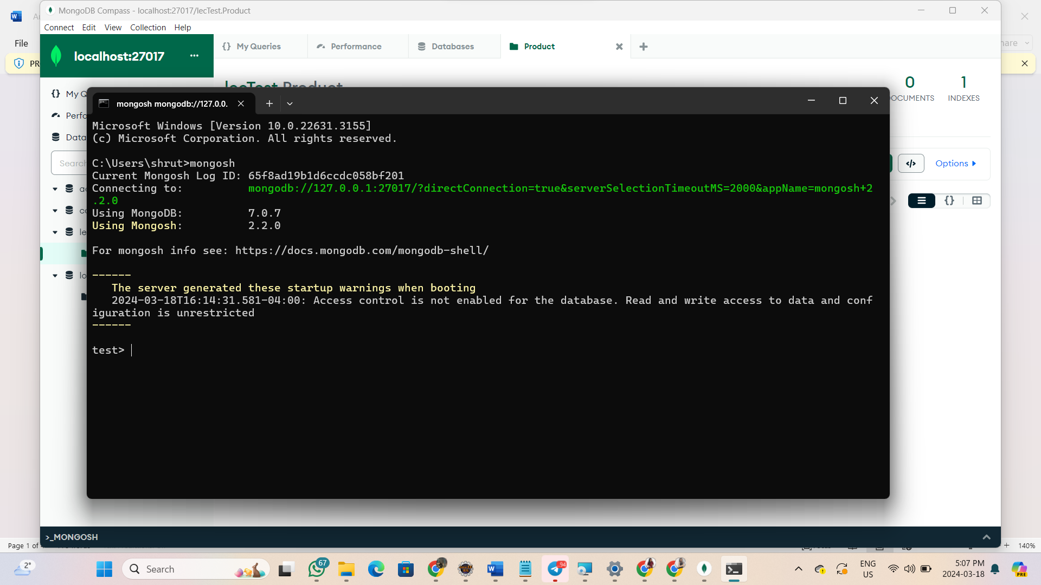

▪ If you are using Atlas, you can simply run mongosh “connection string”

* + cls to clear the screen

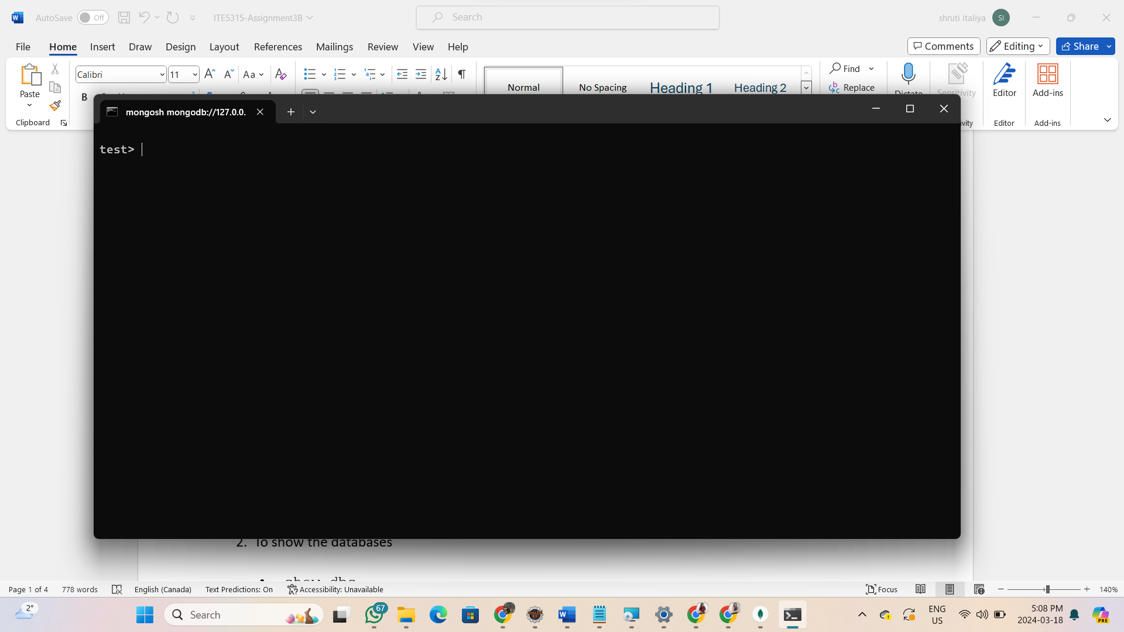

1. To show the databases
   * show dbs

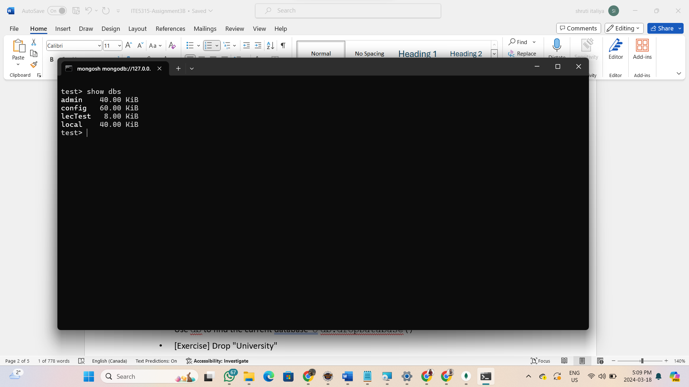

* + use dbname will use and switch to that database.

o If there’s no database, this command will create one.

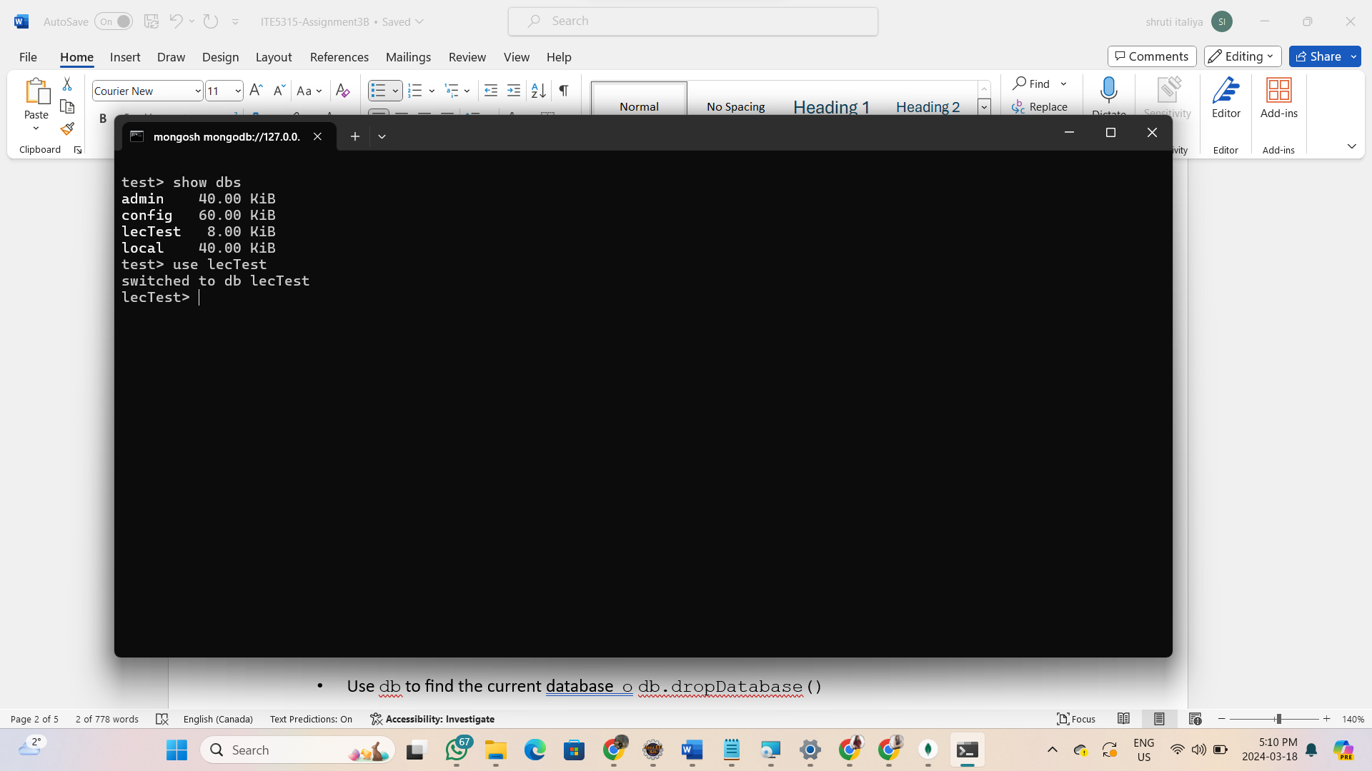

* + db will tell you current db

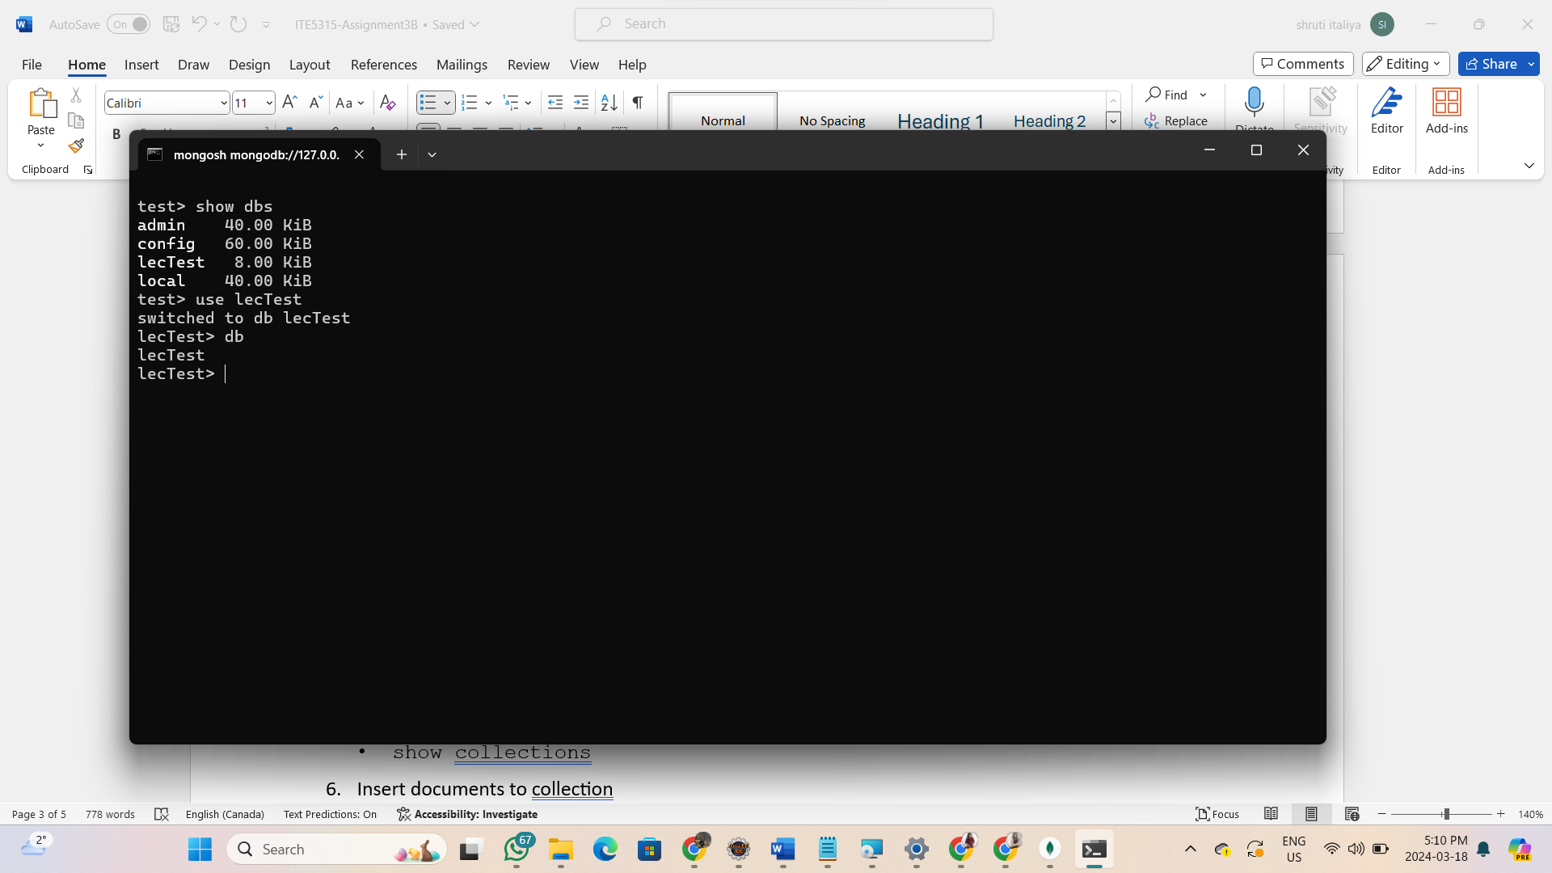

* + [Exercise] Create a database “Company” (in local mongoDB)

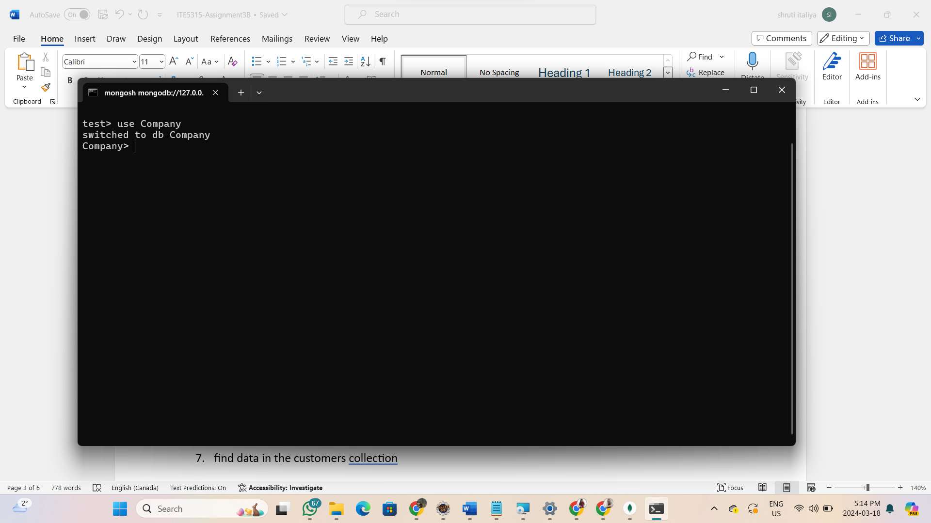

* + [Exercise] Create a database “University” (in local mongoDB)

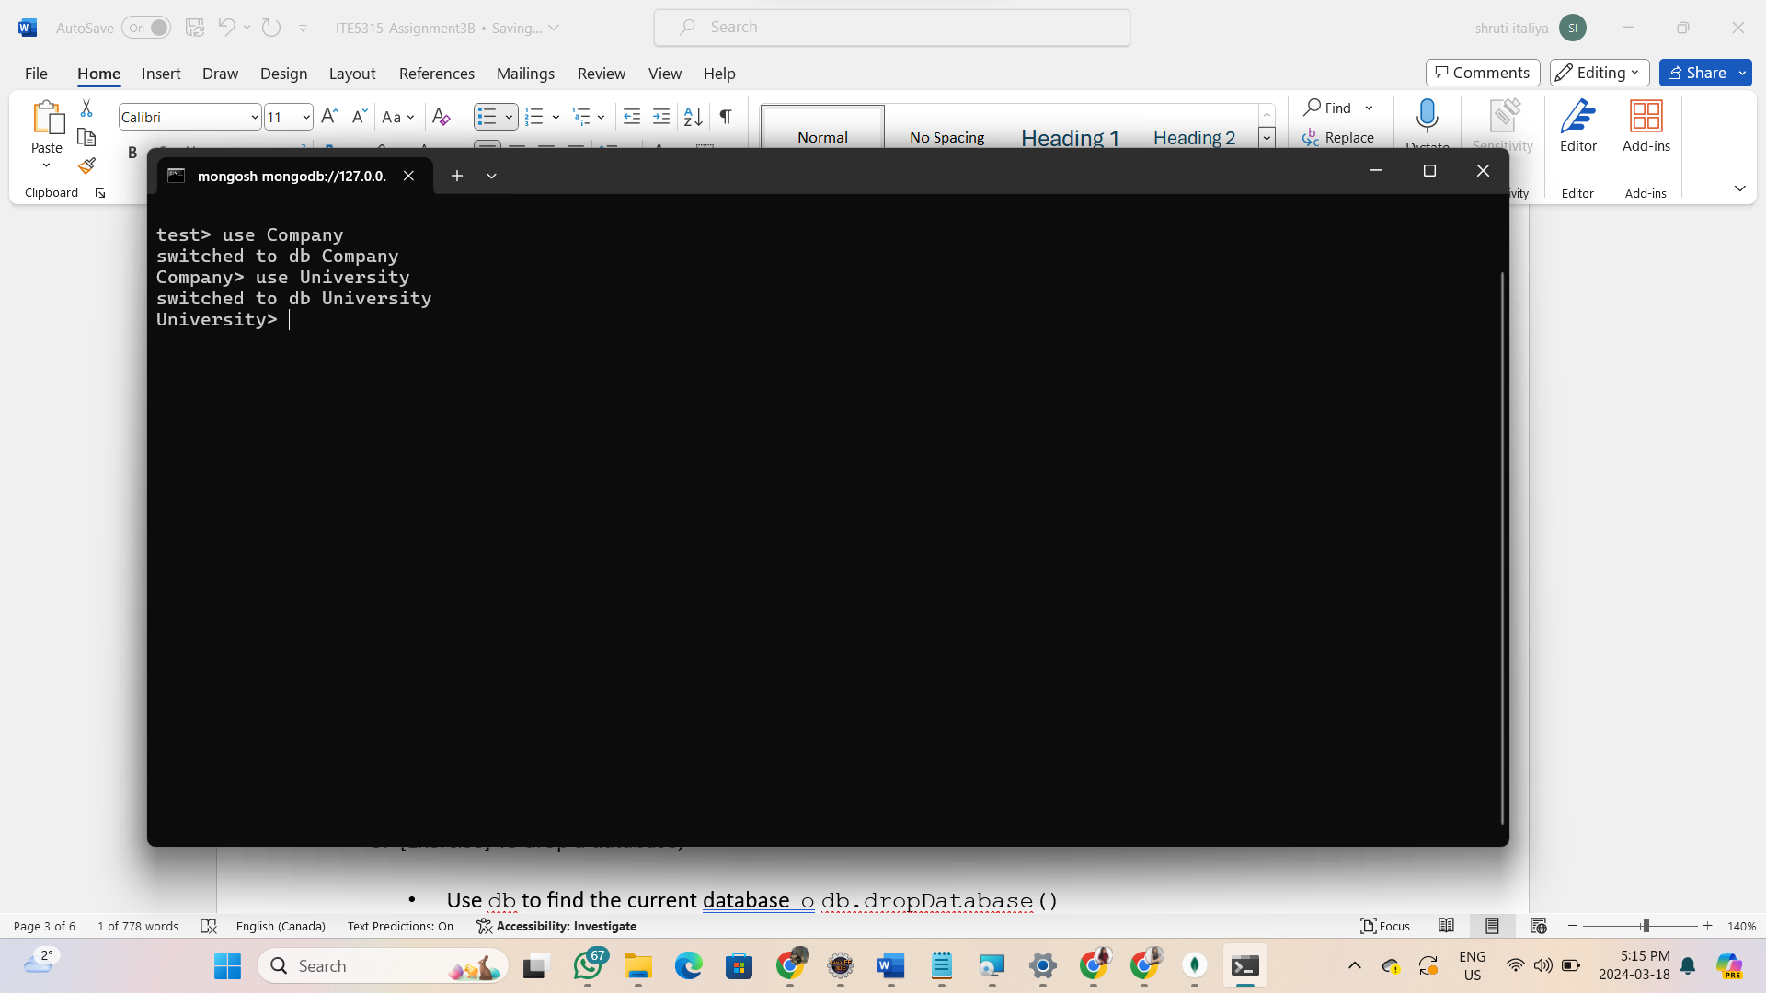

1. [Exercise] To drop a database,
   * Use db to find the current database o db.dropDatabase()

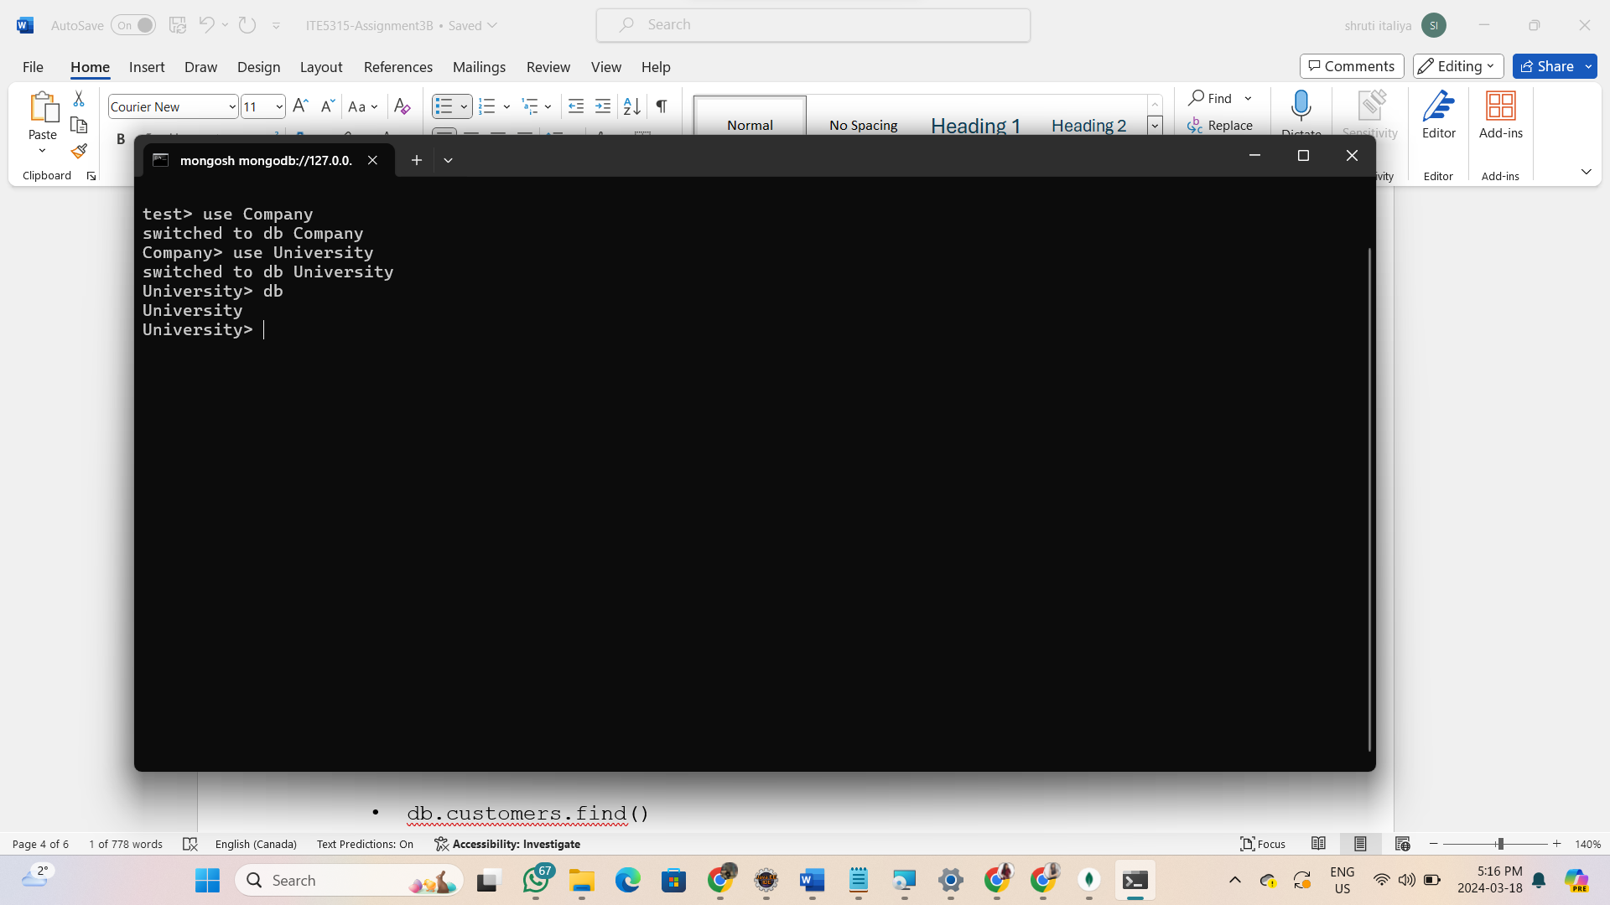

* + [Exercise] Drop "University"

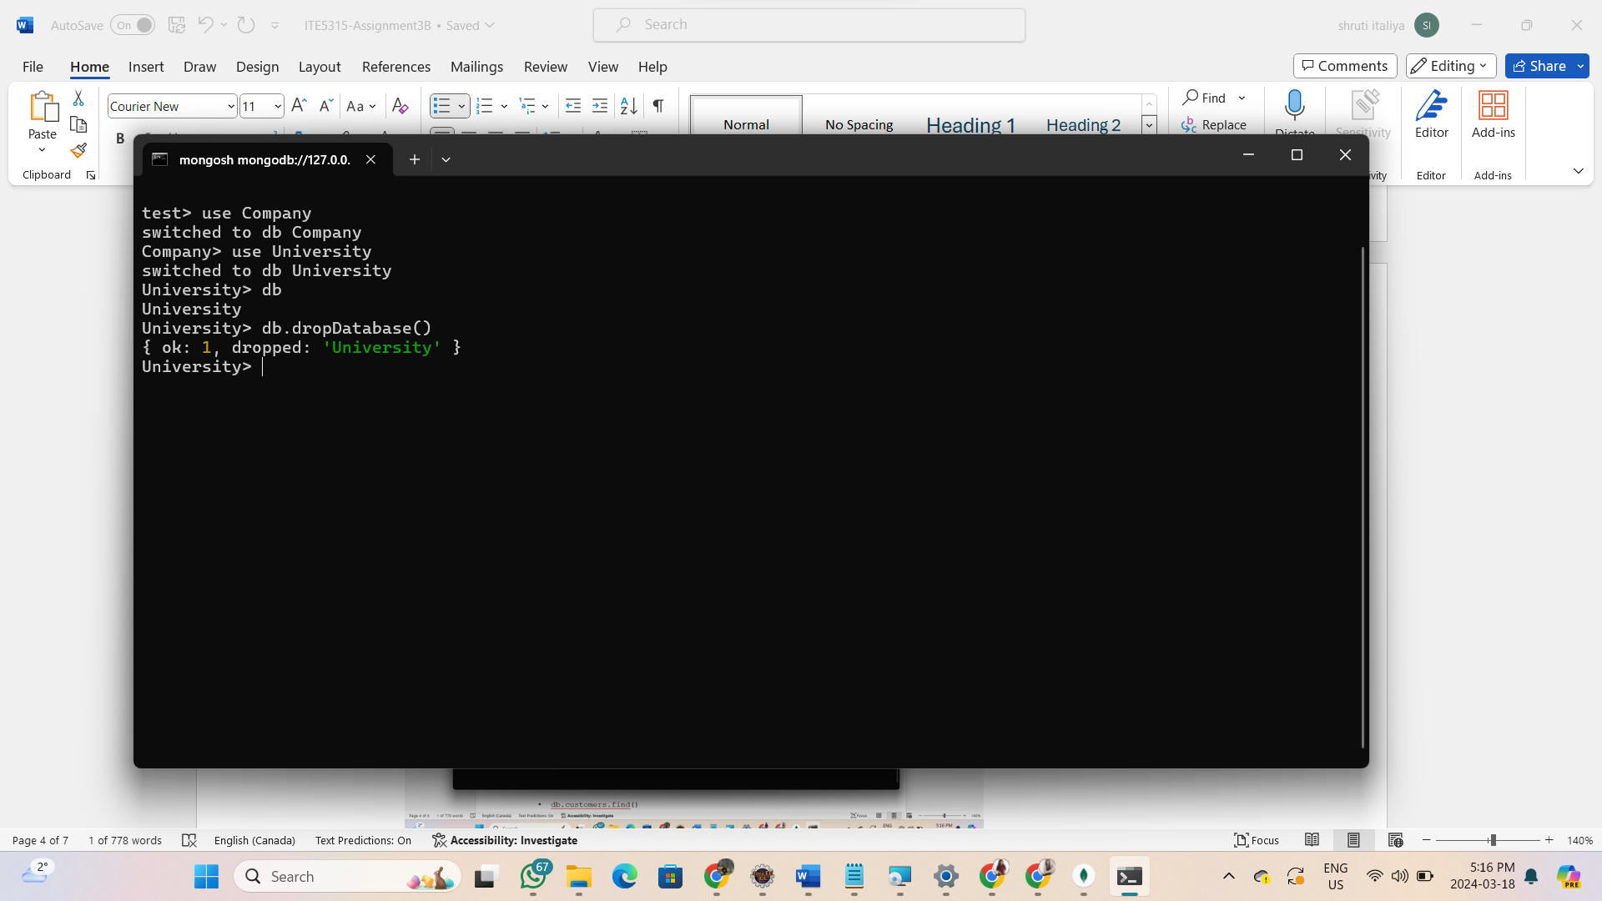

1. Create a collection “customers” for Company database:
   * db.createCollection(‘customers’)

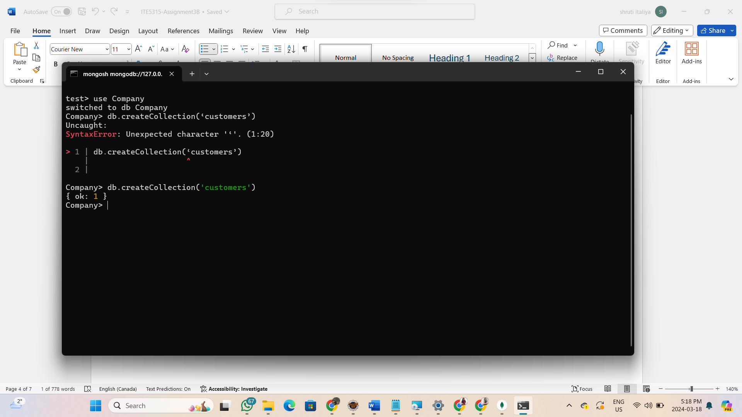

* + show collections

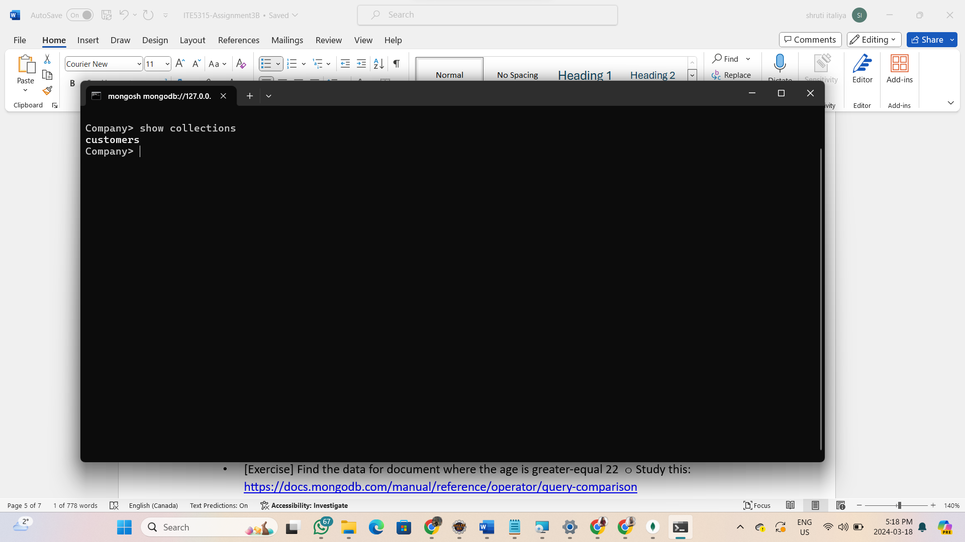

1. Insert documents to collection
   * db.customers.insert({first_name:"Jon", last_name:"Doe", age: "23"})

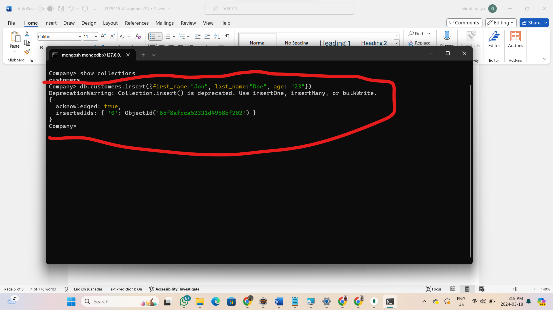

* + [Exercise] Create 5 customers and the fields for their first_name and last_name:
  + John Smith (22), Alicia Zelaya (25), Mona Wallace(20), Allen Borg(26) , yourname

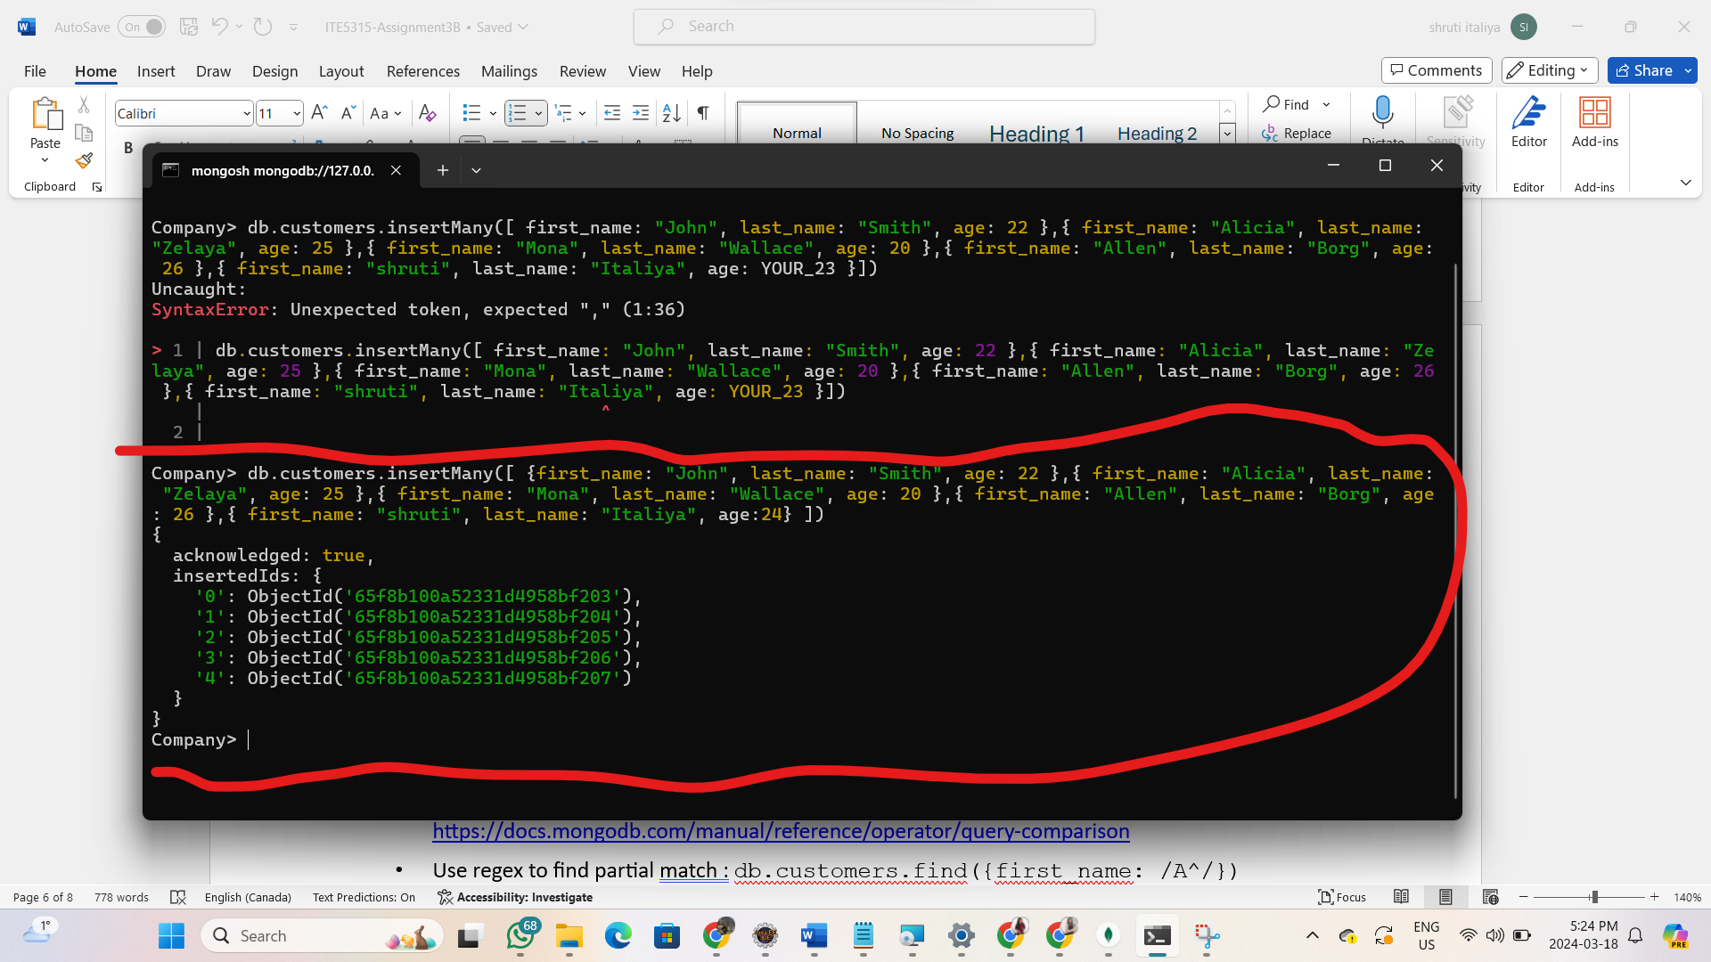

1. find data in the customers collection
   * db.customers.find()

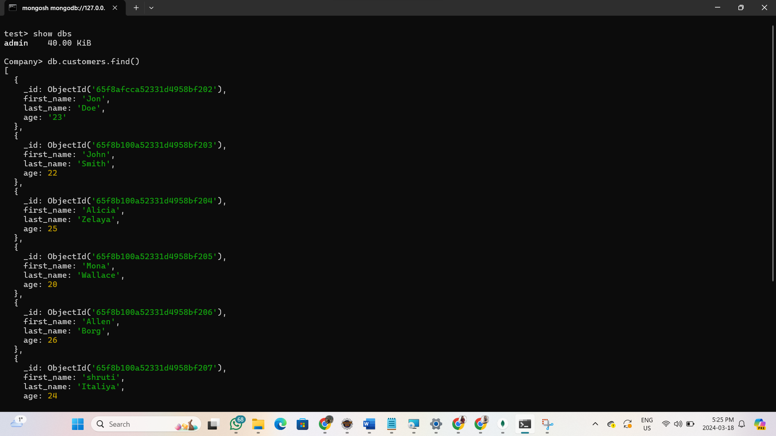

* + db.customers.find().pretty()
  + 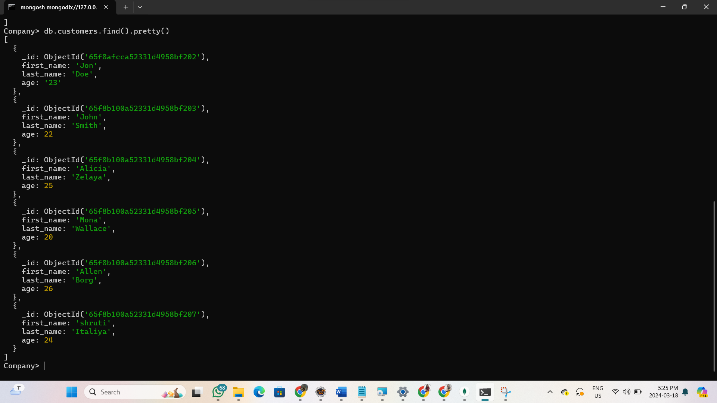
  + db.customers.find({first_name:{$eq:"Alicia"}})

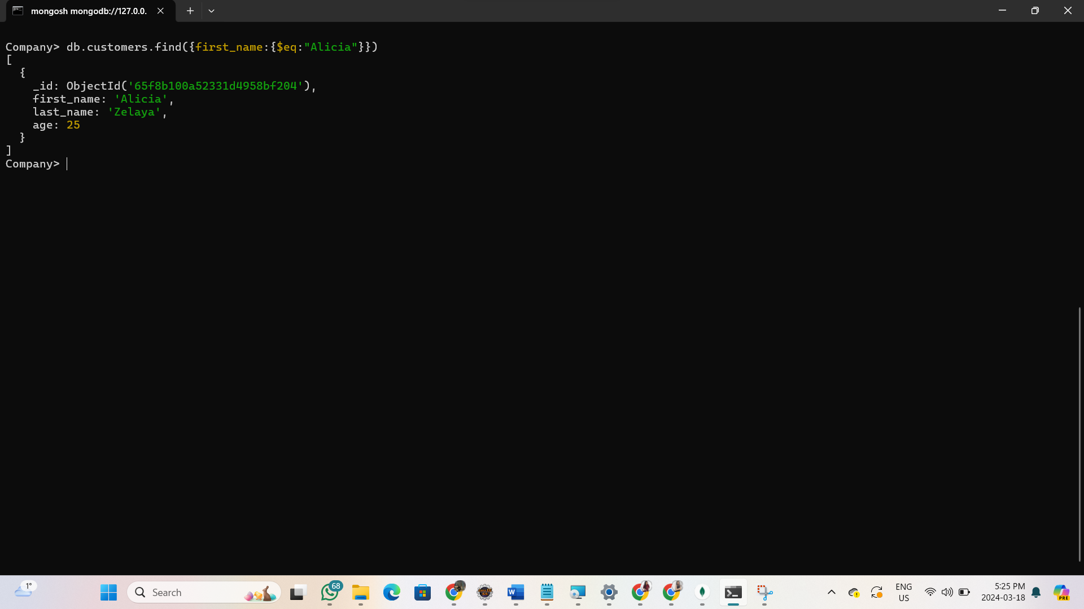

* + [Exercise] Find the data for document where the first_name is Jennifer

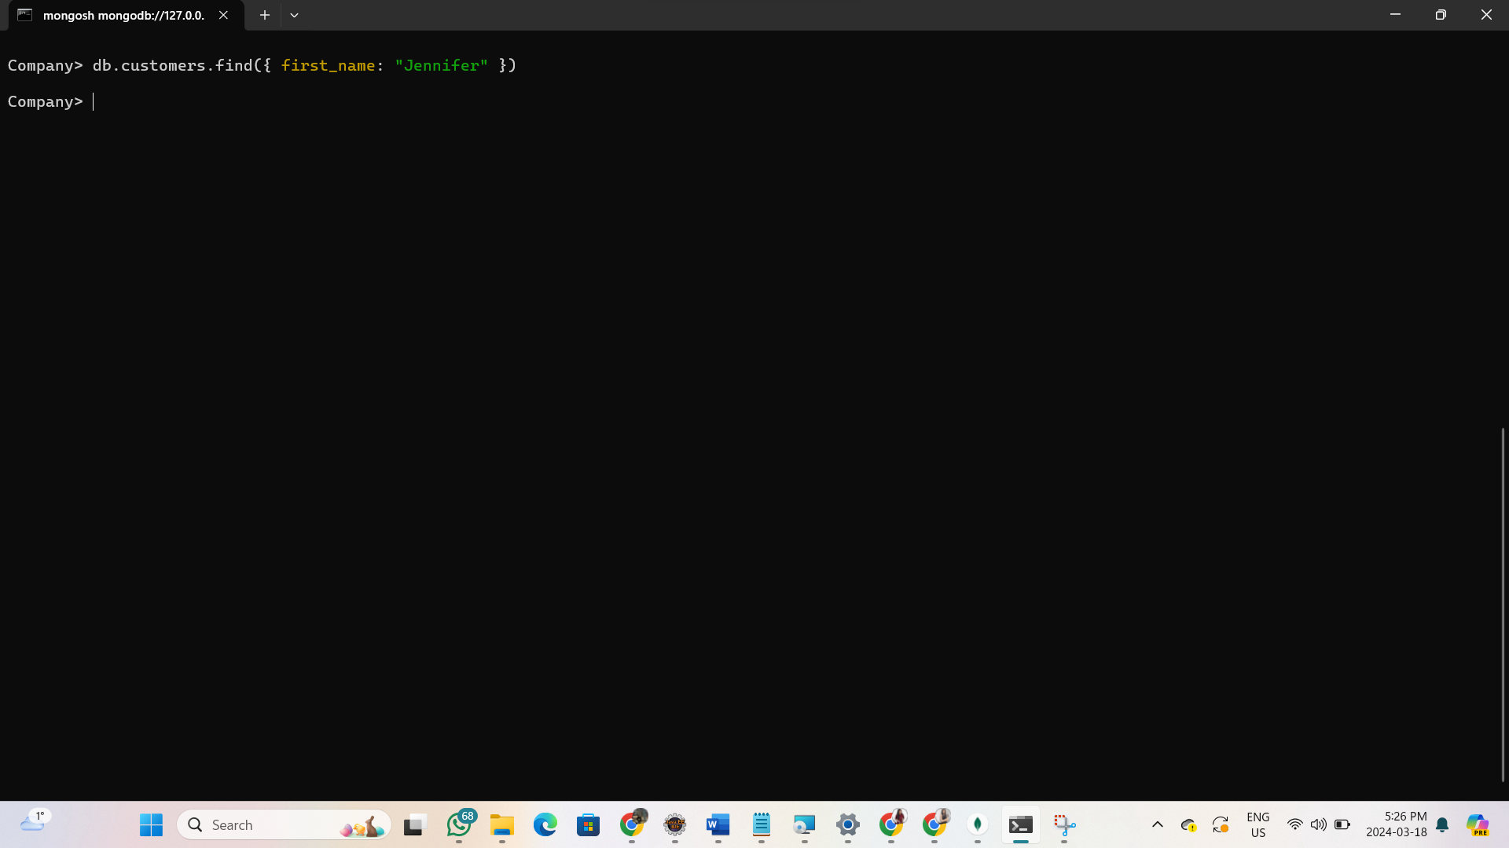

* + [Exercise] Find the data for document where the age is greater-equal 22

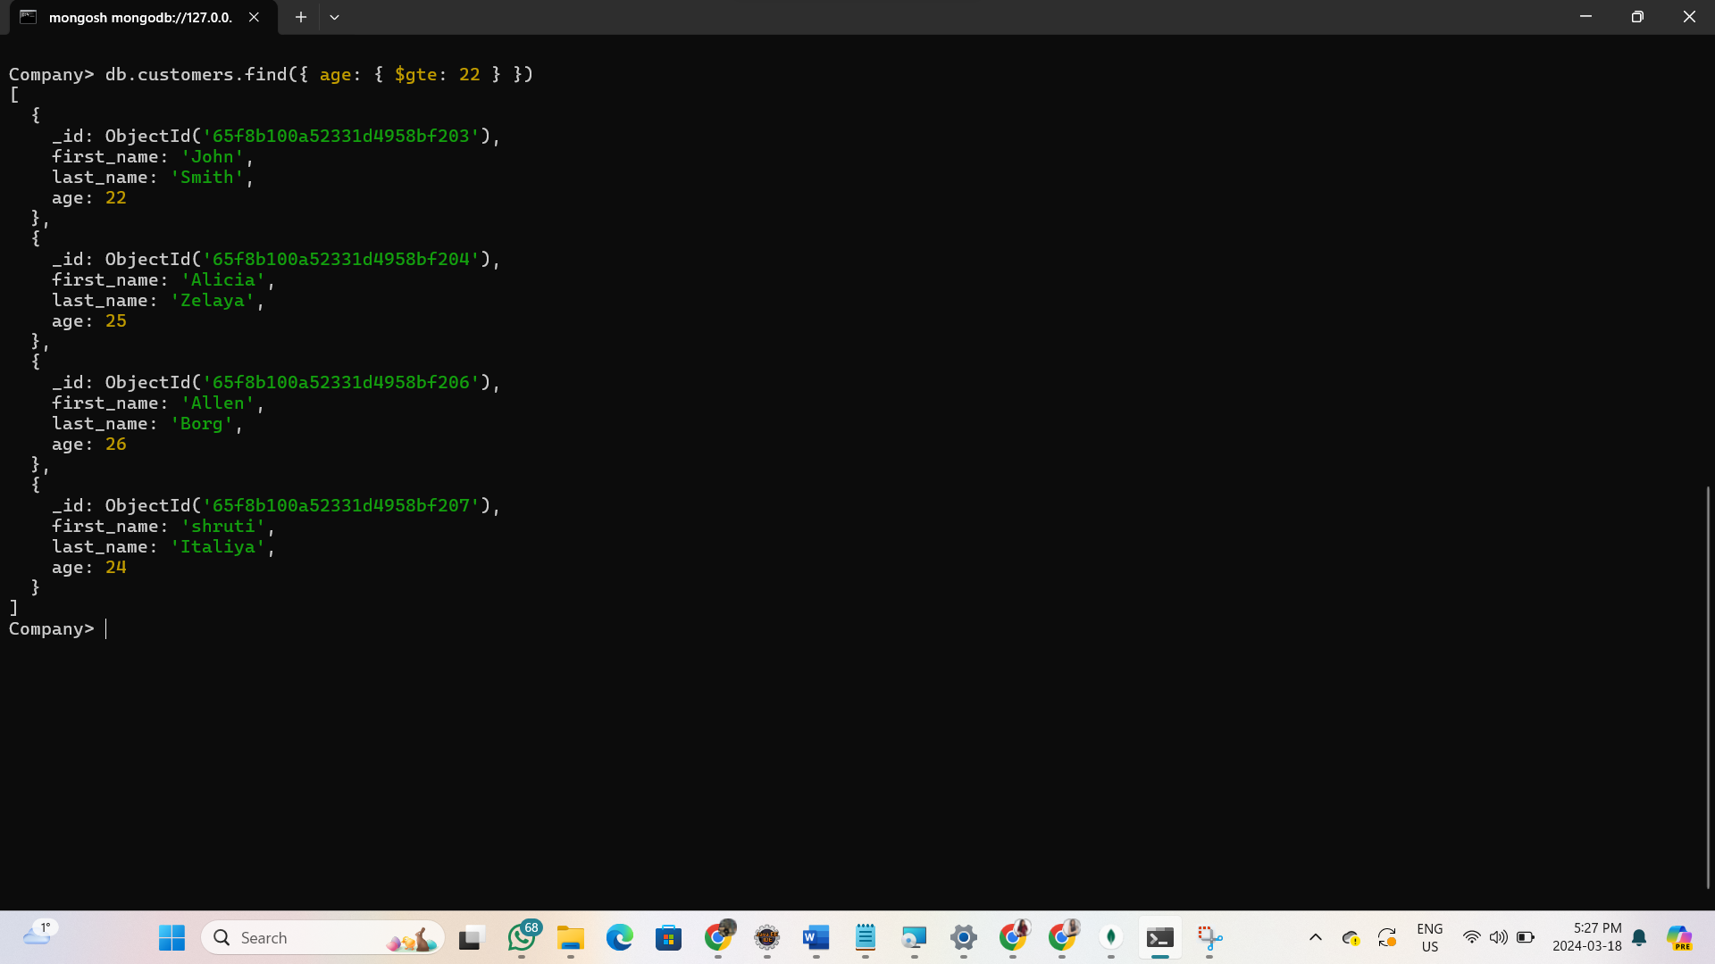

* + Study this: <https://docs.mongodb.com/manual/reference/operator/query-comparison>
  + Use regex to find partial match : db.customers.find({first_name: /A^/})

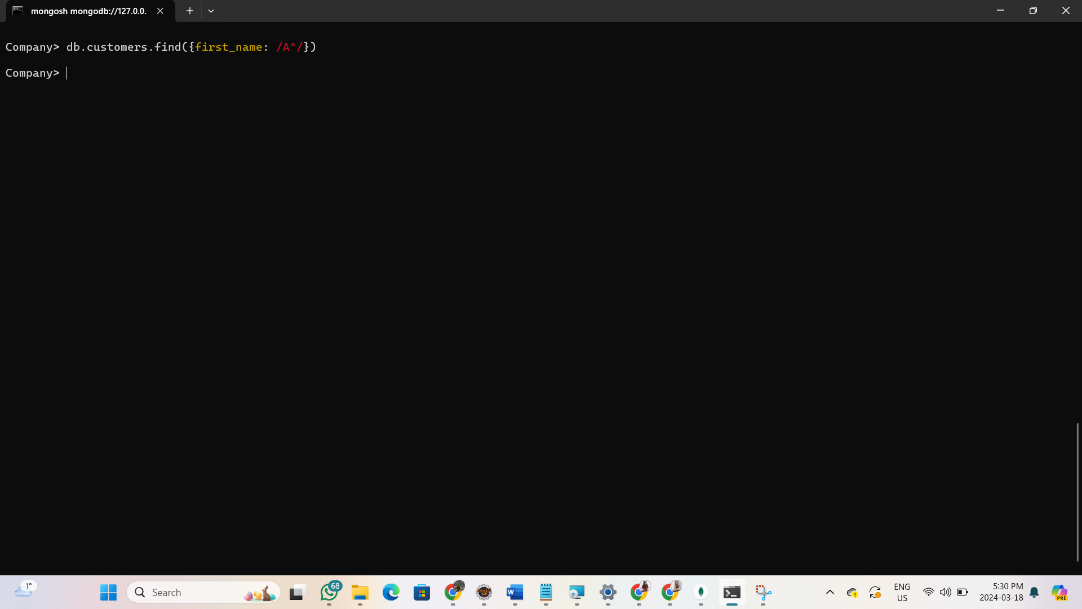

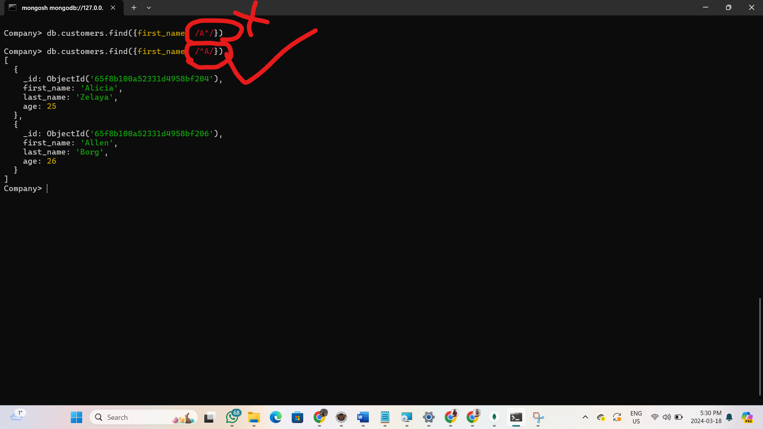

* + Projection to whitelist fields to pass into output : db.customers.find({}, {first_name: true})

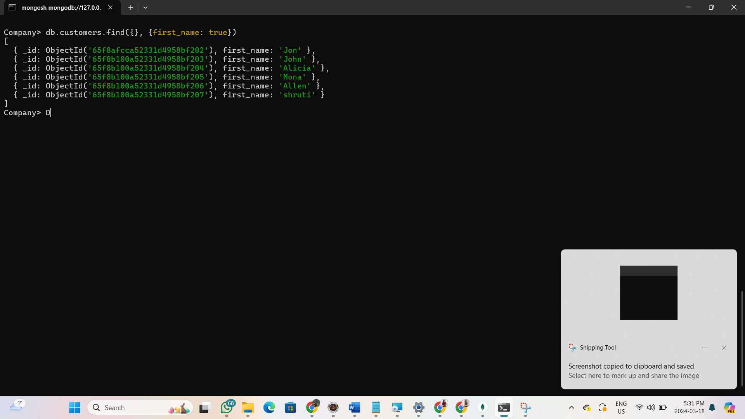

* + use the $or operator: : db.customers.find({$or:[ {age:{$gt:22,

$lte:25}},{last_name:/a/}], {first_name: 1, age:1})

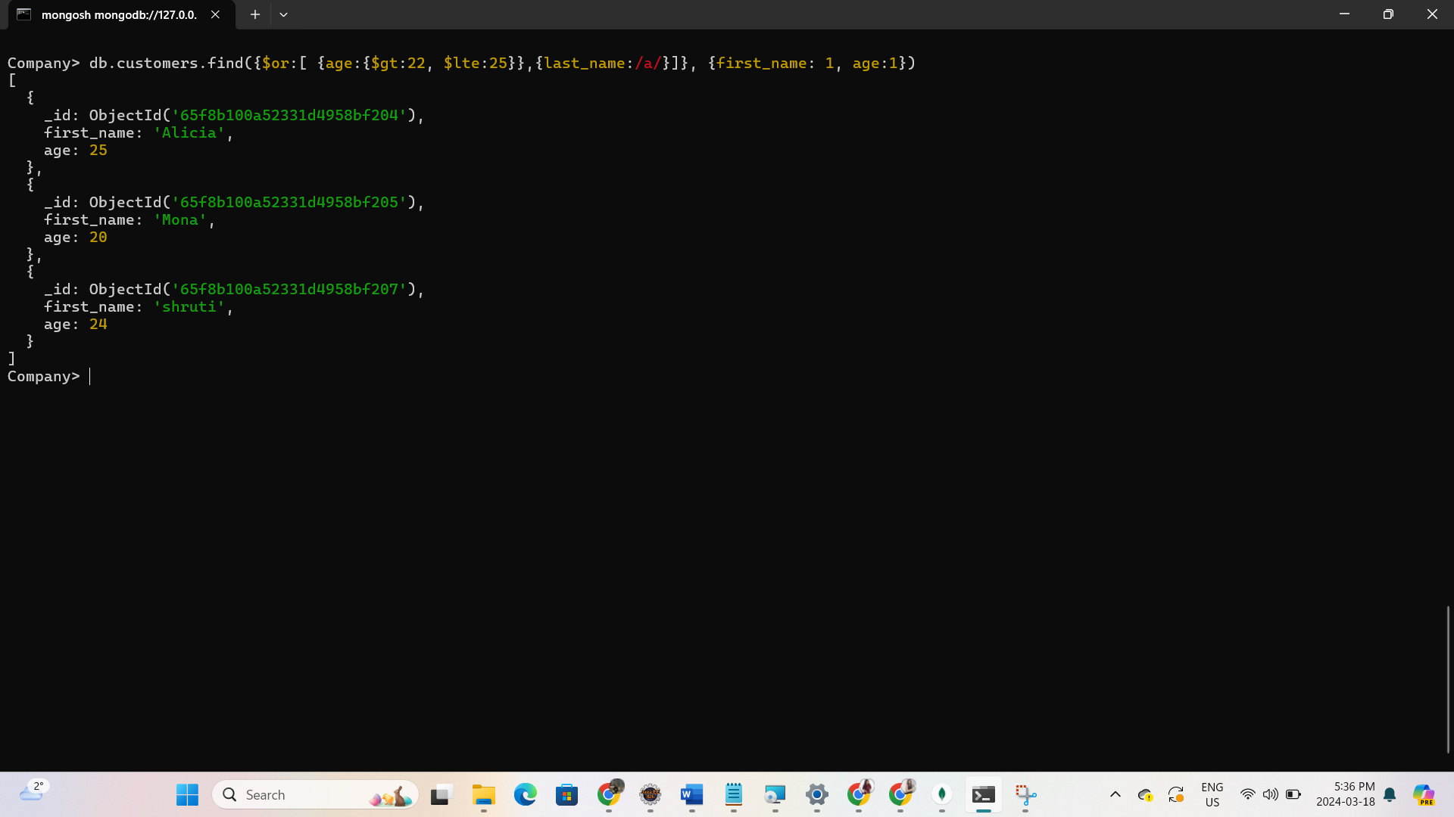

1. Multiple documents at once using array format
   * db.customers.insert( [ {first_name:"Sam", last_name:"Smith"} ,

{first_name:"Jade", last_name:"Smith", age:"26"}]);

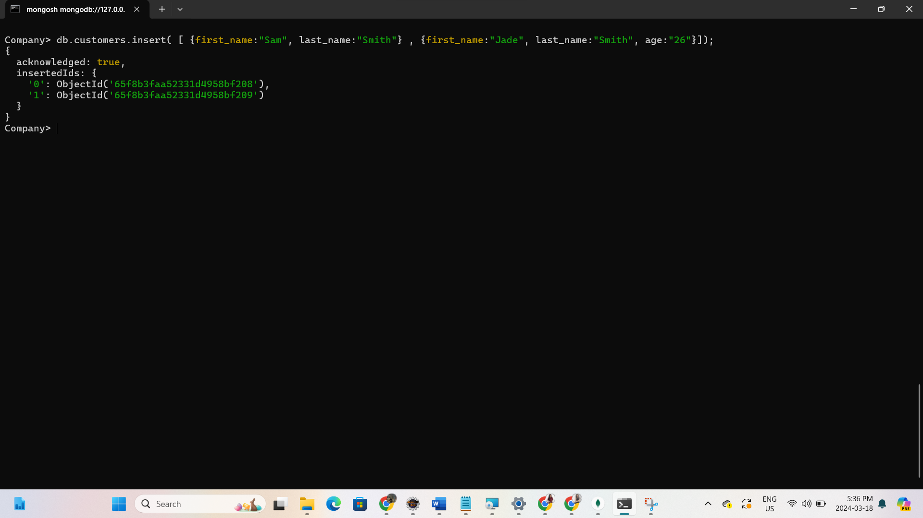

1. [Exercise] use an array to insert following to a database "**petshop**" and collection "**pets**" (instead of adding one-by-one. You can also use other versions of insert command!)

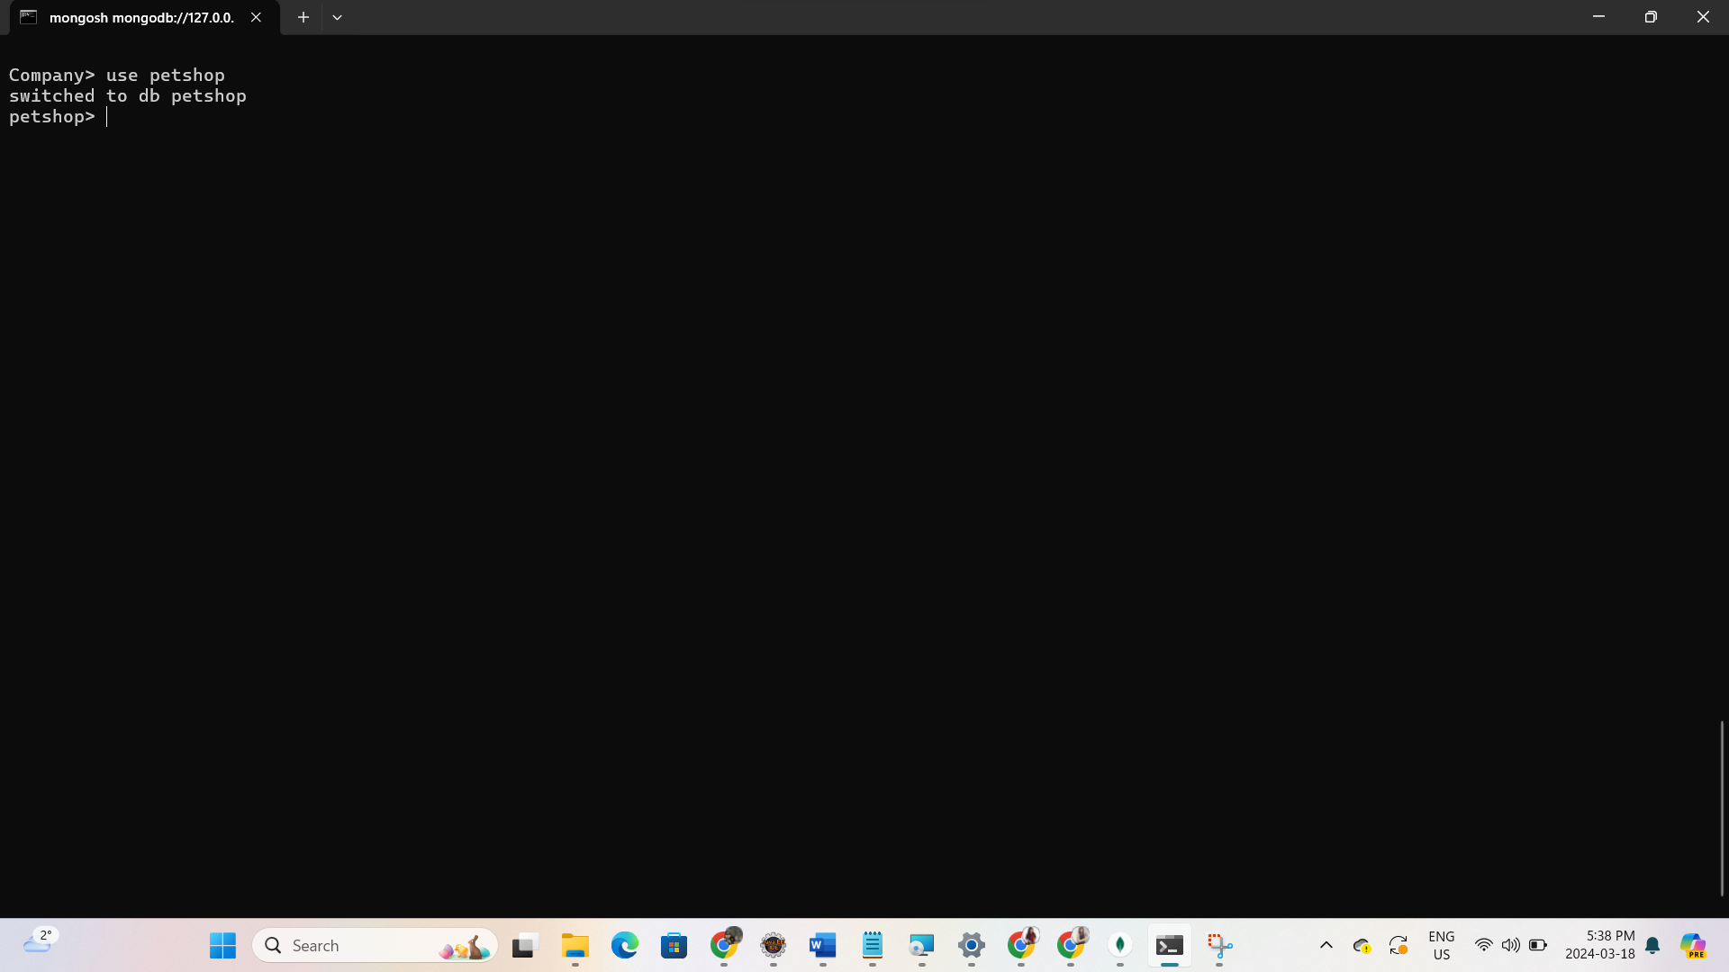

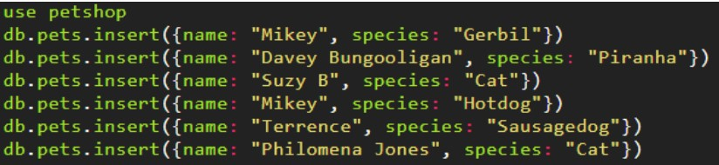

* + Add another piranha called Pete, and a naked mole rat called Henry.

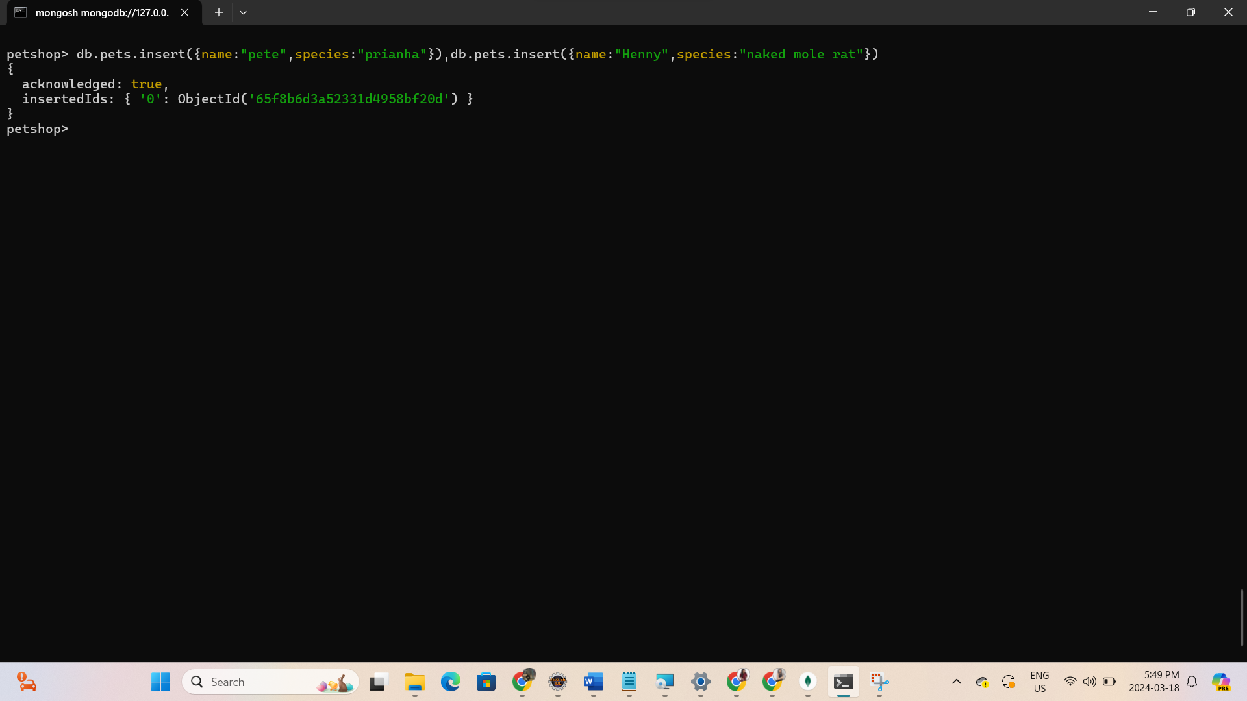

* + Use find to list all the pets. Find the ID of Mikey the Gerbil.

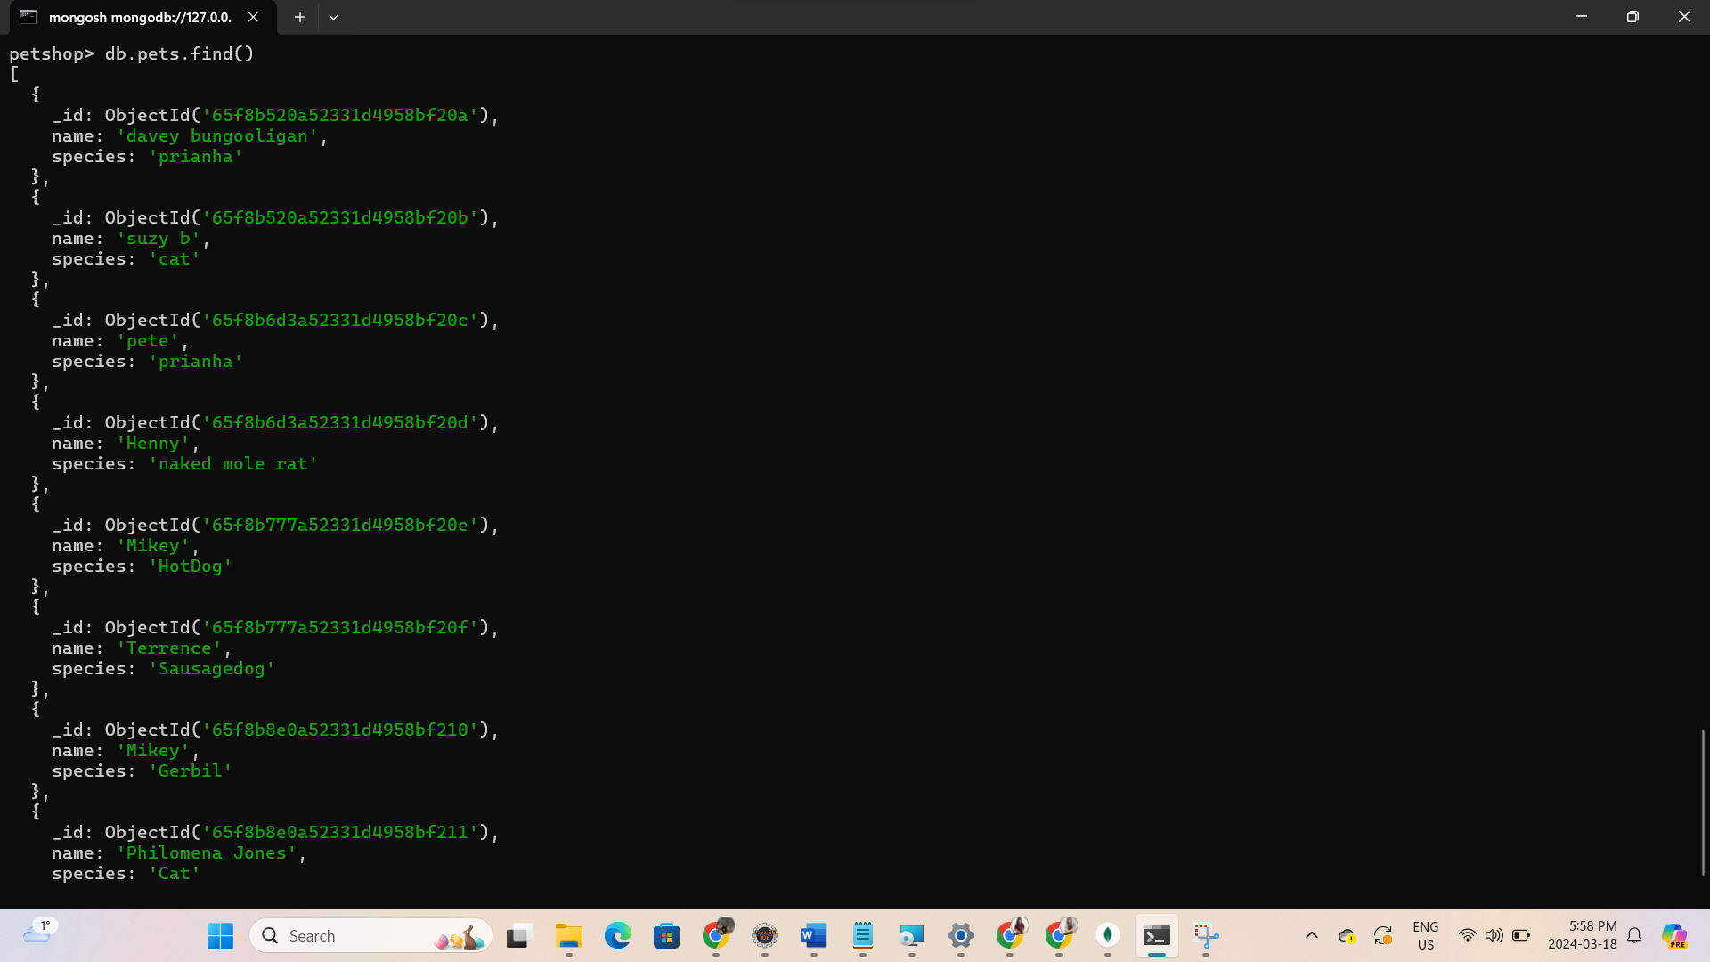

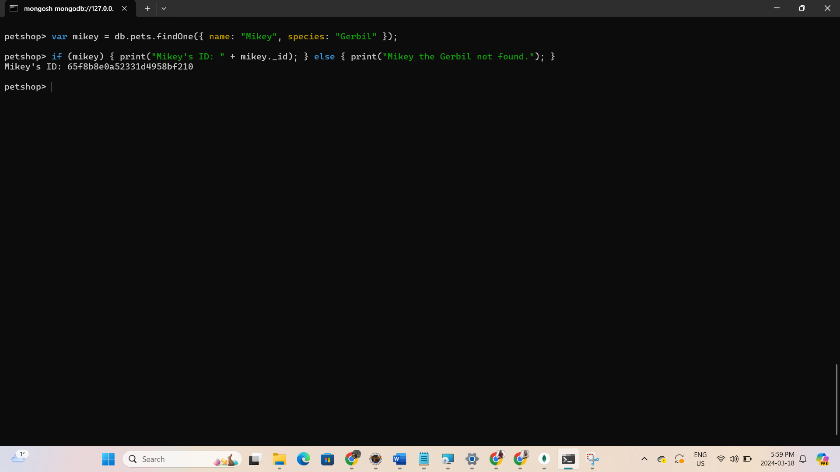

* + Use find to find all the gerbils. o Find all the creatures named Mikey.

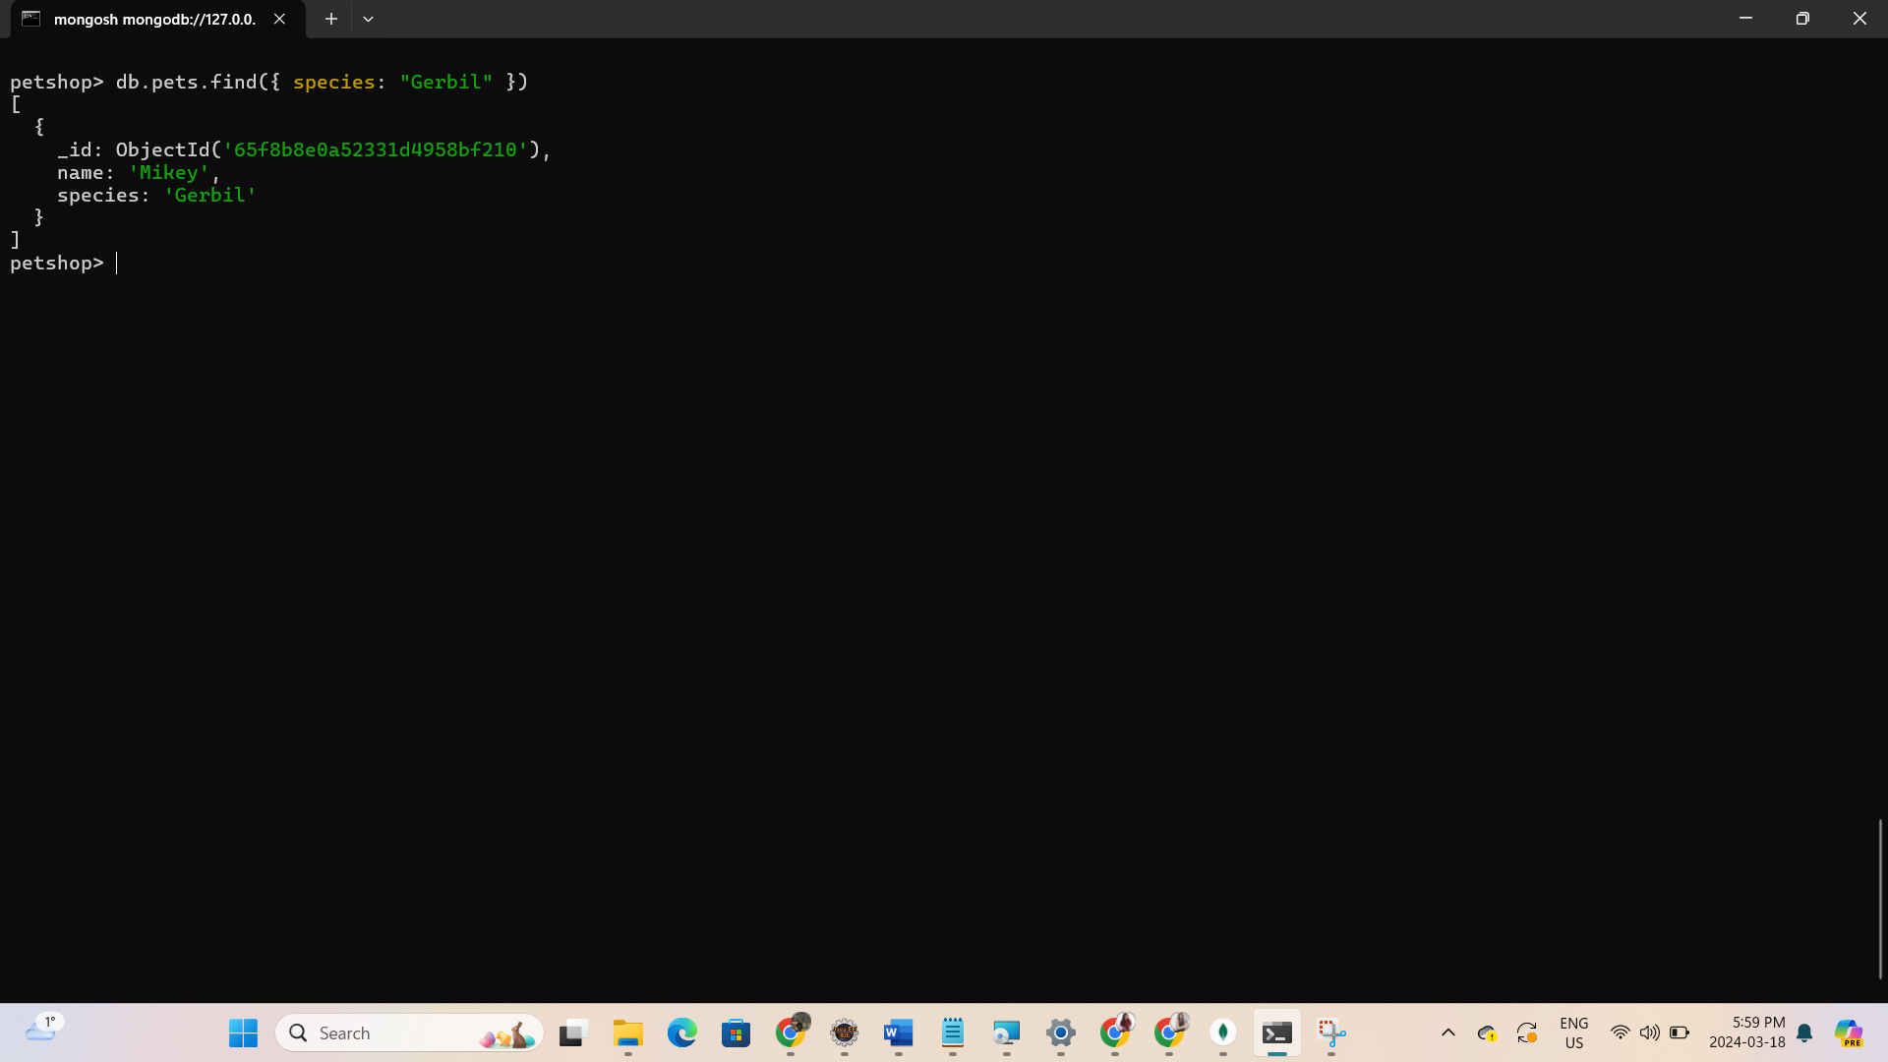

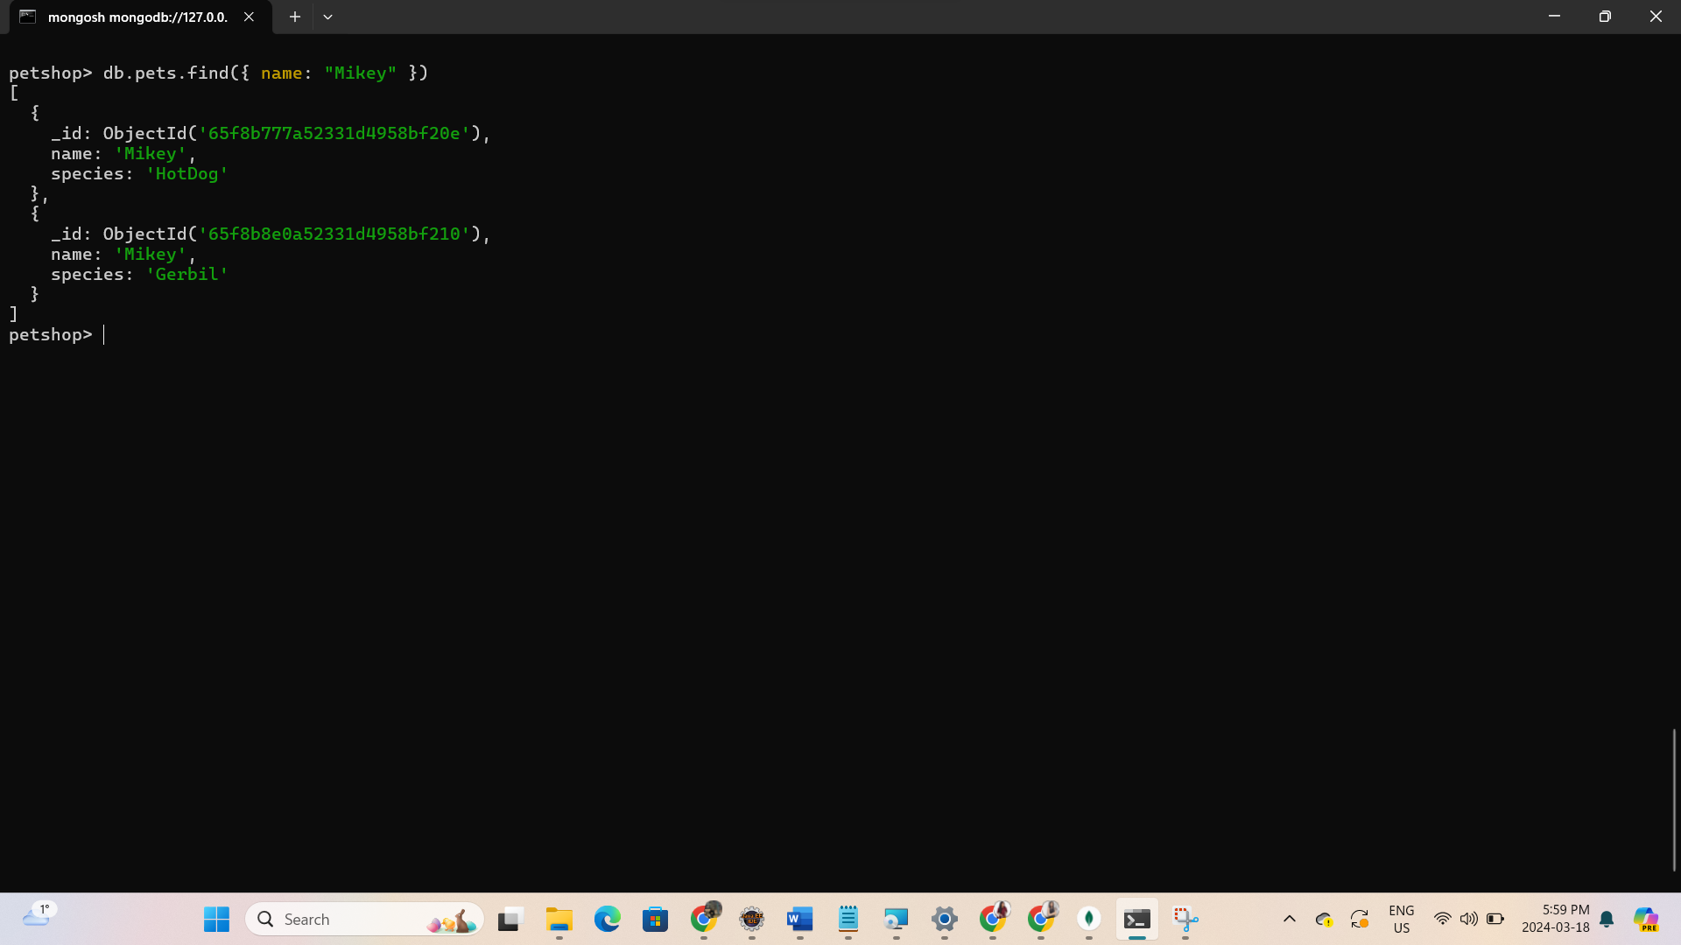

* + Find all the creatures named Mikey who are gerbils.

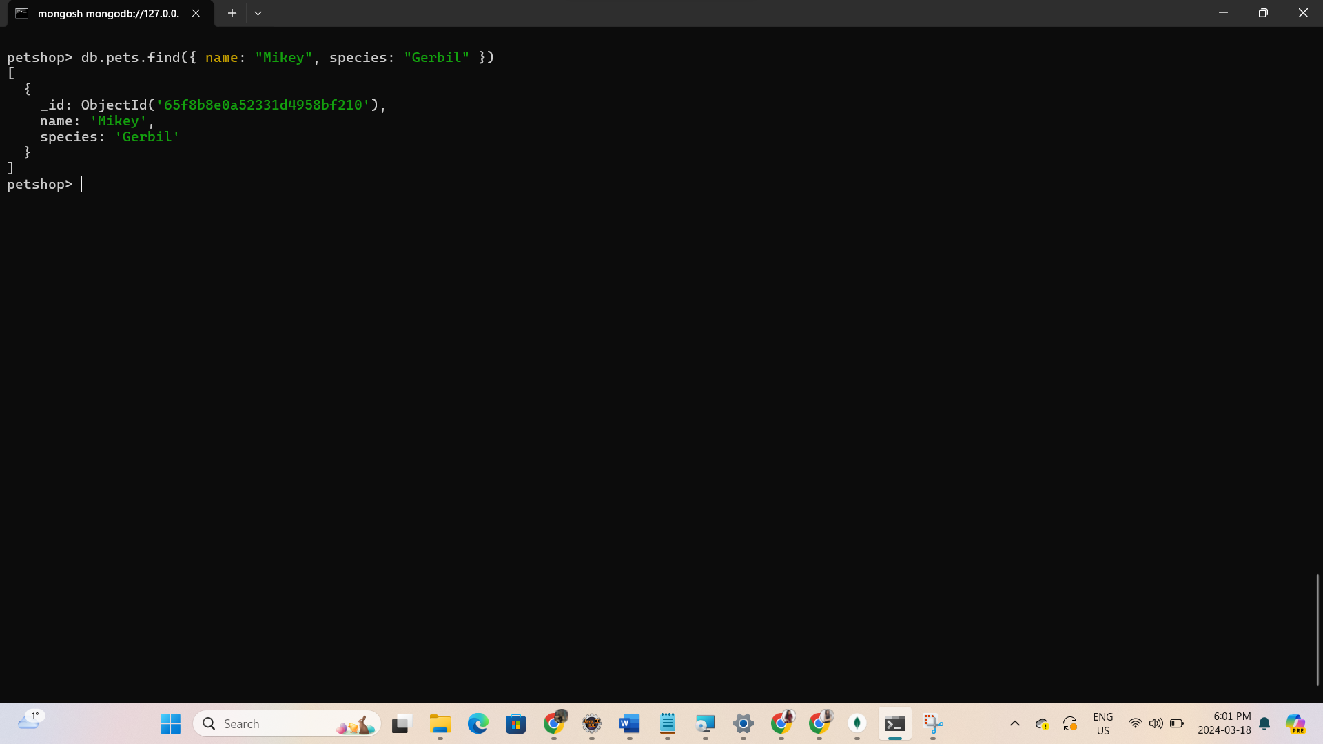

* + Find all the creatures with the string "dog" in their species

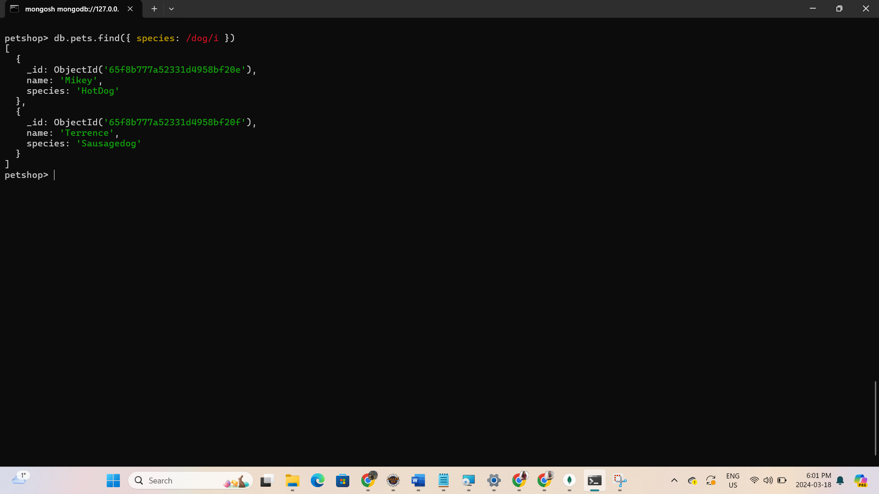

1. Update
   * db.customers.update({first_name:"Sam"}, {first_name:"Sam", last_name:"Smith", age:"24"})
   * Note: You need to repeat all the fields with their data. Otherwise document will replace by just the fields available in the update statement.

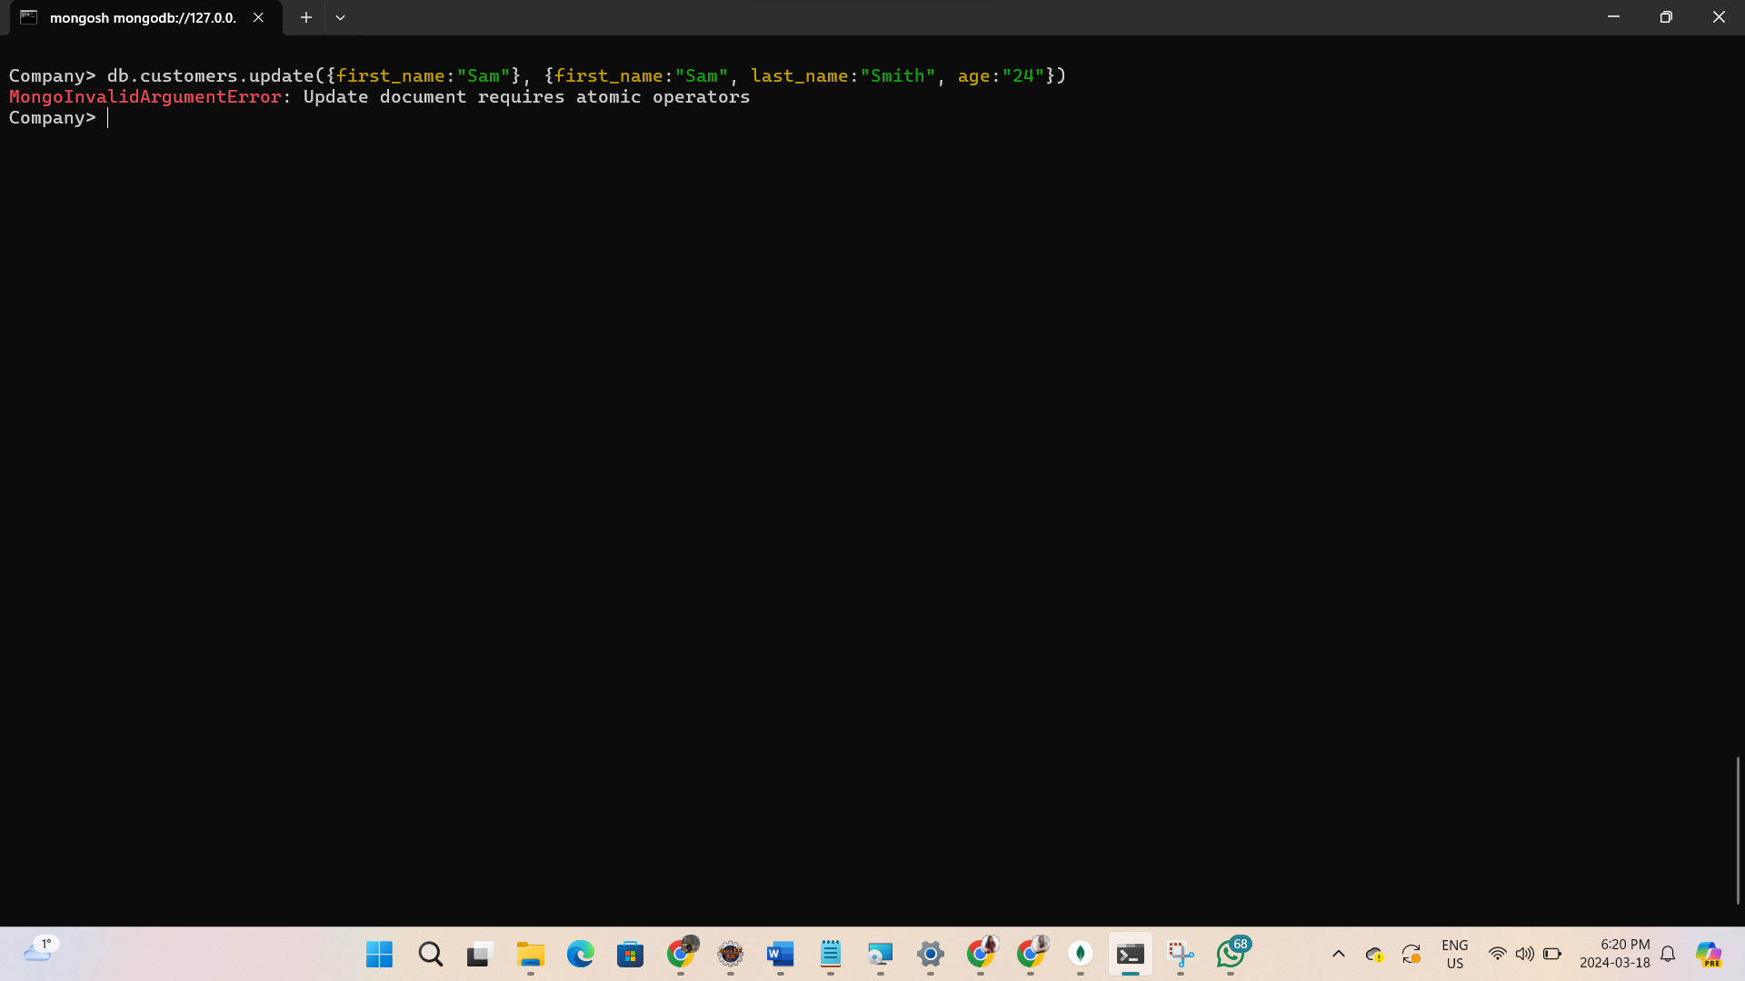

* + Use the $set operator instead.

o Use the set operator for that db.customers.update(

{first_name:"Jade"}, {$set:{age:"28"}} );

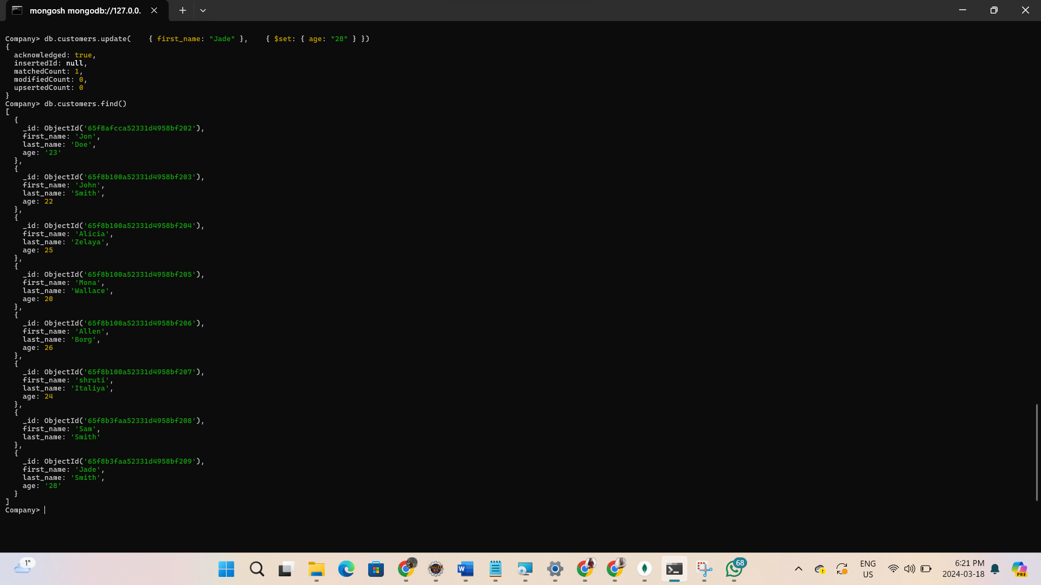

* + [Exercise] Update all the customers to include custType field with value “gold”.

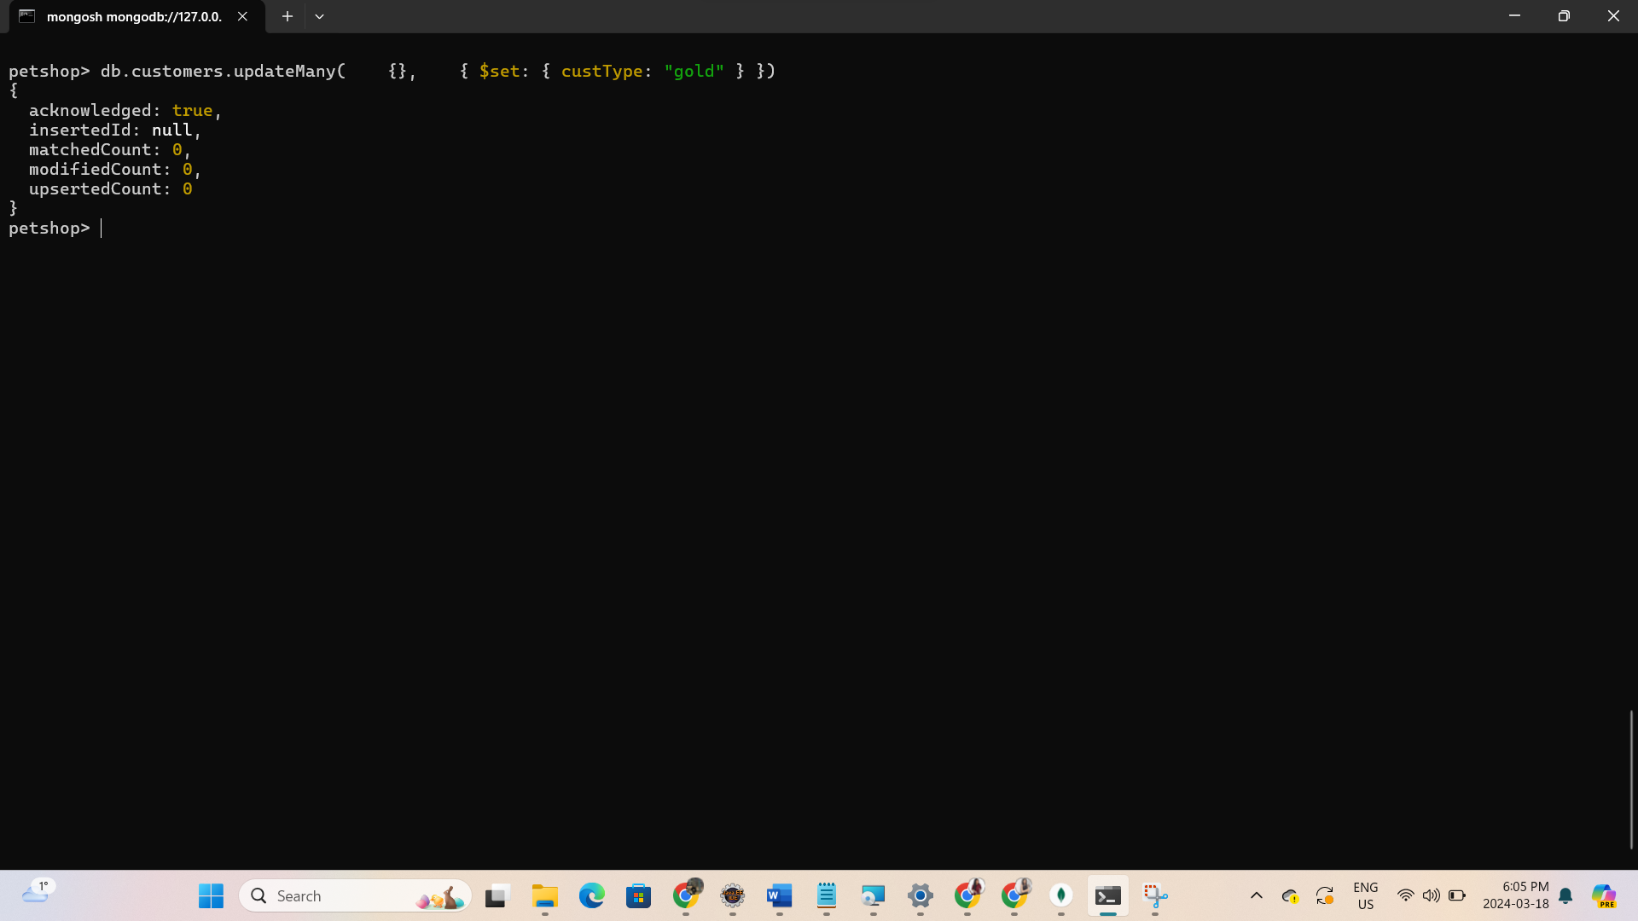

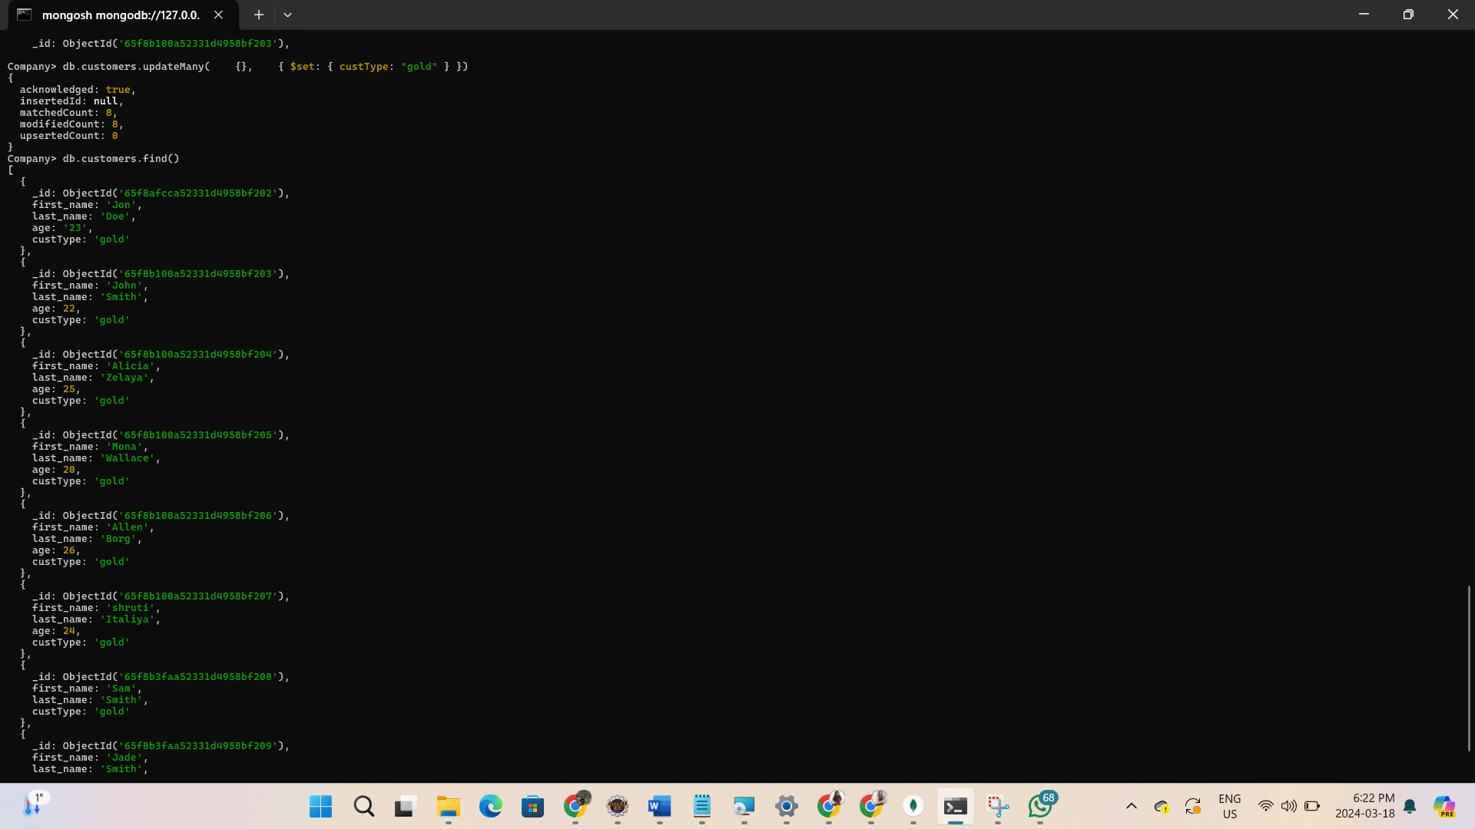

* + Use inc operator to increment numerical values

o db.customers.update( {first_name:"Sam"}, {$set:{age:40}} );

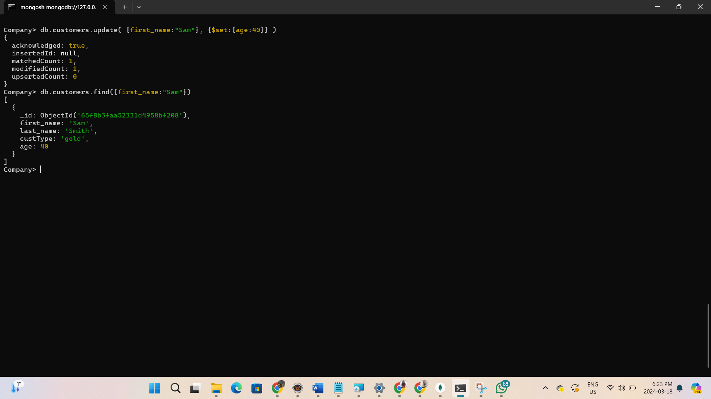

o db.customers.update( {first_name:"Sam"}, {$inc:{age:5}} );

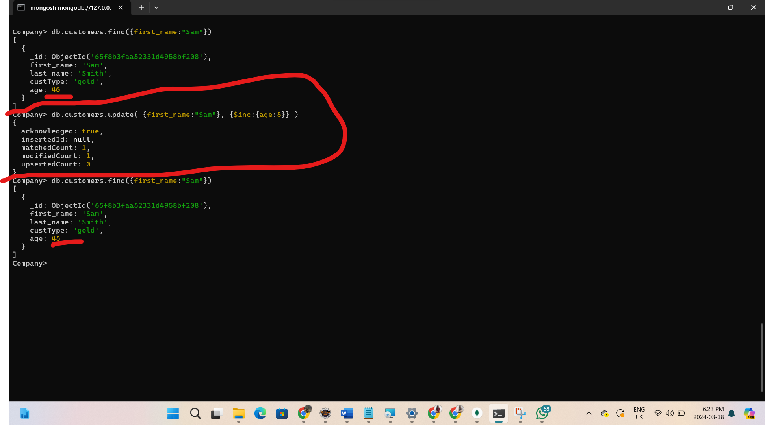

* + Use unset to remove a field {$unset: {field1:"", …}}
* db.customers.update( {first_name:"Sam"}, {$unset:{age:""}} );

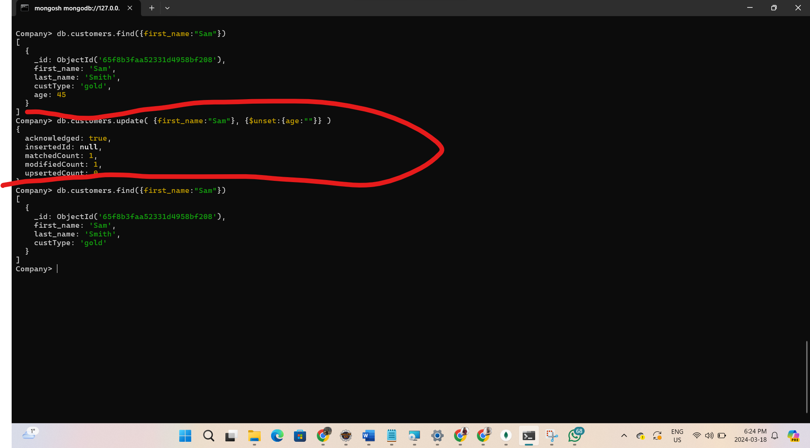

* + Use the upsert to insert if the update fails because document is not there

o db.customers.update( {first_name:"May"}, {first_name:"May", last_name:"June"}, {upsert: true});

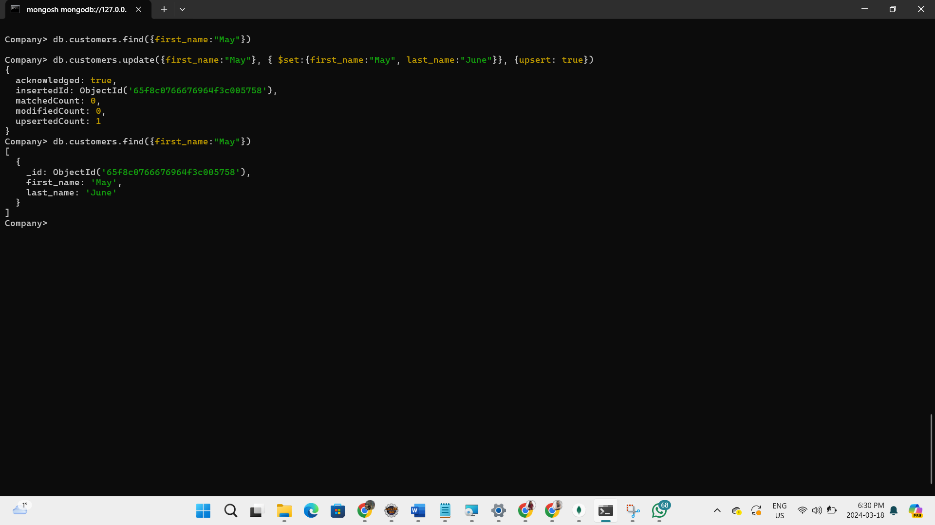

1. Remove/delete document
   * + db.customers.remove( {first_name:"May"}, {justone: true})

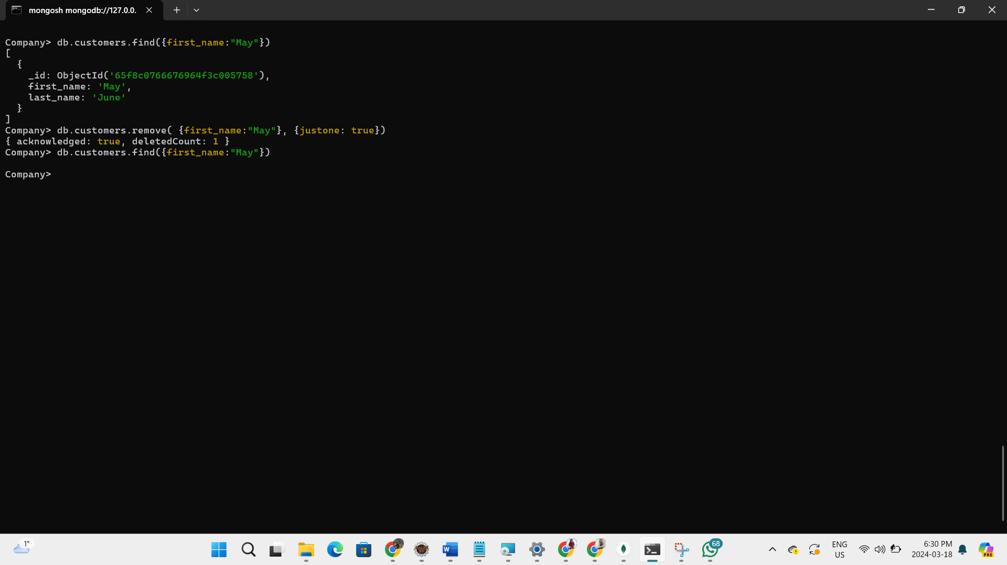

* + justone will delete only first document it finds, otherwise it will delete all

1. To import json files to the database, Exit from the mongo: type "exit" and then use mongoimport. But you need to download mongoimport and install it in **mongodb\bin** folder (use this video tutorial: <https://www.youtube.com/watch?v=n_mdEM9iPCE> ) and then type the following in the command line

(Your path should still be mongodb\bin)

* + [Exercise] First download the **stock.json** file and save it in bin folder, then run the following command to import it:

o mongoimport --db stocks --collection stocks --file stocks.json

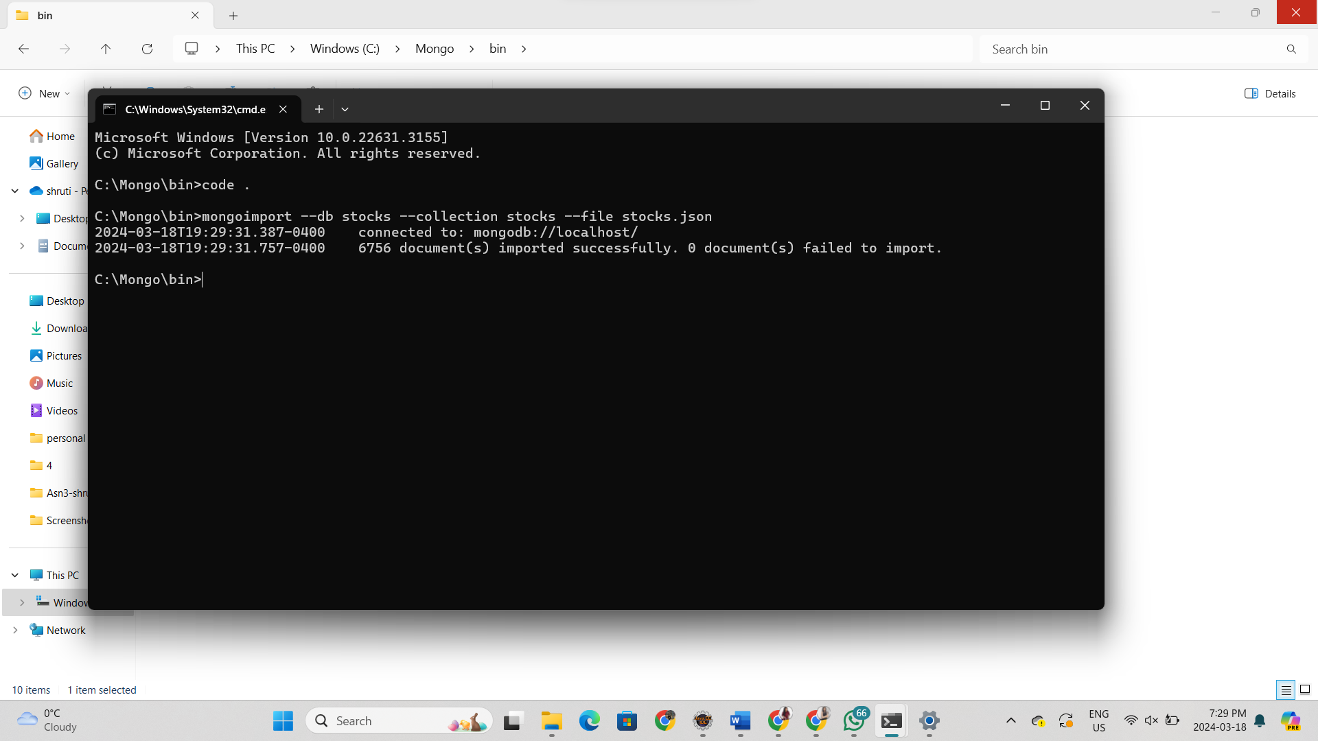

* + [Exercise] Show all data in the imported collection.

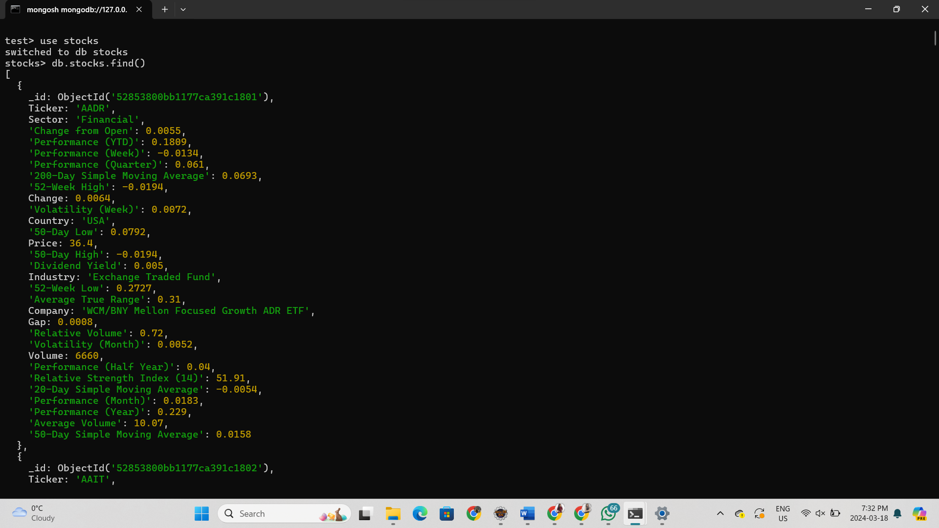

* + [Exercise]Using the same idea, try to import the **sample.json** to your Atlas!

o Show all data in the imported collection.

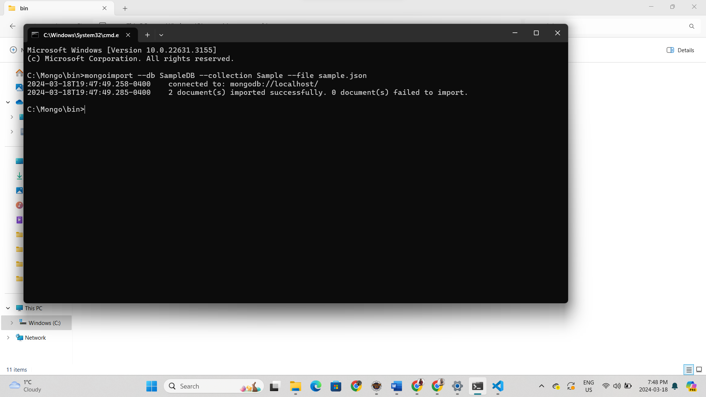

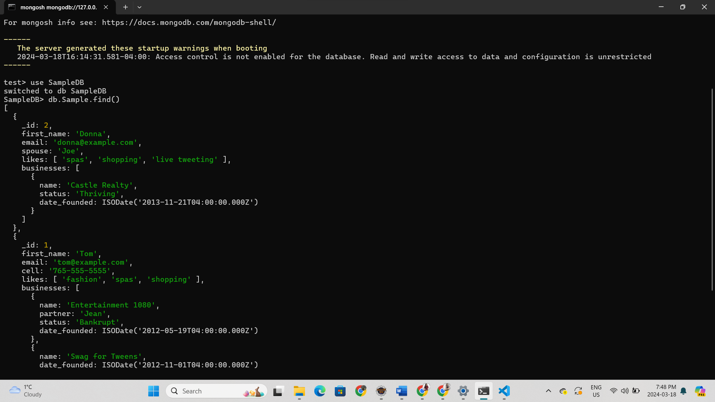

Assignment Submission:

* + Complete all steps, Add all screenshot and explanations (if required) to MS-Word file.
  + Add the following declaration at the top of MSWORD file

/****************************************************************************** ***

* + - ITE5315 – Assignment 3
    - I declare that this assignment is my own work in accordance with Humber Academic Policy. * No part of this assignment has been copied manually or electronically from any other source * (including web sites) or distributed to other students.

*

* + - Name: ___________________ Student ID: _______________ Date: ____________________

*

*

******************************************************************************

**/

Important Note:

* + **LATE SUBMISSIONS for assignments**. There is a deduction of 10% for Late assignment submissions, and after three days it will grade of zero (0).
  + Video recording is not required for this assignment